 | J. Mater. Environ. Sci., xxxx, Volume x, Issue X, Page xxx-xxx  http://www.jmaterenvironsci.com | Journal of Materials and  Environmental Sciences  ISSN : 2028-2508  CODEN : JMESCN  Copyright © 2017,  University of Mohammed Premier  Oujda Morocco

Kinetics and equilibrium studies on biosorption of cadmium and lead ions from aqueous solutions by chemically modified algae Bifurcaria bifurcata

N. Benzidia¹, A. Saih², F. Bentiss³, C. Jama⁴, S. Bakkas¹, L. Khamliche^{1*}
¹ Laboratory of Organic Chemistry, Bioorganic and Environment,Faculty of Sciences, University of Chouaïb Doukkali,
El Jadida, Morocco.
² Laboratory of computing, mathematics and their applications, Faculty of Sciences, University of Chouaïb Doukkali,
El Jadida, Morocco.
³ Laboratory of Catalysis and Corrosion of Materials, Faculty of Sciences, University of Chouaïb Doukkali, El Jadida, Morocco.
⁴ University Lille, CNRS, INRA, ENSCL, UMR 8207, - UMET - Unit of Materials and Transformations, University Lille,
F-59000 Lille, France.
Abstract
This study examined the removal of Cd(II) and Pb(II) ions by adsorption using chemically modified algae bifurcaria bifurcata. Batch adsorption experiments were conducted to examine the effects of pH, contact time, biomass concentration, and initial metal concentration on the elimination process. The optimum sorption conditions for each heavy metal were quantified. The experimental data were analyzed using Langmuir and Freundlich isotherms. The results showed that the equilibrium of the biosorption is well described by the Langmuir isotherm. The kinetic data were adjusted to include both pseudo first order and pseudo-second order models. The obtained results showed that the pseudo-second order kinetic model well describes the biosorption of Cd(II) and Pb(II) ions with a maximum biosorption capacity of 71 and 277.77 mg.g⁻¹, respectively. A linear regression was performed as statistical analysis to evaluate kinetic models and adsorption isotherms.

Received 08 Sep 2017,
Revised 19 Nov 2017, Accepted 25 Nov 2017

Keywords
- Biosorption,
- Cadmium,
- Lead,
- Bifurcariabifurcata,
- Algae.

Khamliche@yahoo.fr; Phone: +212 661251521; Fax: +212 523342187

- Introduction
Water, the first natural resource in the world, is increasingly threatened by pollution. Waste, organic and inorganic toxic substances are released into the aquatic environment: oceans, and rivers [1-2]. Among the inorganic pollutants, heavy metals are extremely hazardous since they are non-biodegradable and have the capacity to accumulate in living organisms. Moreover, the majority of treatment plants are not equipped to purify polluted water by these substances. Lead and Cadmium are considered to be the most toxic and dangerous to the environment [3-4]. Lead is used in printing, metallurgy, manufacture of batteries and certain pigments used in paints [5]. Cadmium is used in anti-corrosion coatings of metals and rechargeable batteries. It is also involved in many alloys, in electric fuses and cables as well as in bars for nuclear reactors. In its ionic form Cadmium is also used as stabilizers for plastics, pigments, alkaline batteries, photoelectric cells and luminescent substances for television [6].
Releases from these industries cause contamination of the aquatic environment. The exposure of organisms to heavy metals can have serious health effects and is mainly due to water consumption and the food chain. Indeed, Lead and Cadmium can cause neurological damage, liver and kidney effects, and even cancers [4-6]. Thus, eliminating heavy metals becomes a priority to minimize their effects on human health and to preserve the environment. There are several methods for the removal of heavy metals from an aqueous solution: adsorption on activated carbon, reverse osmosis, ion exchange, chemical precipitation and membrane filtration [7-8]. However, economic factors may limit their use [9]. One of the emerging and attractive technologies for removing heavy metals from aqueous solutions is the biosorption process. Various biomass such as bacteria [10], yeasts [11], fungi [12-13] and algae [14] have been studied as biosorbents for the removal of heavy metals.
The aim of this work is to study the kinetics of biosorption of Cd(II) and Pb(II) using chemically modified alga bifurcaria bifurcata.
2. Material and Methods
2.1. Chemical pretreatment of biomass
Once collected from the Atlantic coast of the city of El Jadida (Morocco)( figure 1a) , algae Bifurcaria bifurcata were washed with water, dried in an oven at 60 ° C for 24 hours( figure 1b), then ground and sieved to obtain the fraction size of 0,50 mm. The crude material has been activated by successive immersions in solutions of NaOH (0,75 M) ( figure 1c), HCl (0,75 M) ( figure 1b) then NaCl (2 M) ( figure 1d) following a method developed in the laboratory [15].

a) | b) | c) | d) | e)
Figure 1: Bifurcaria bifurcata at different steps of treatment: (a) Algae collected; (b) dried and sieved; (b) after treatement by NaOH; (c) After treatment by HCl; (d) After treatment by NaCl.

2.2. Preparation of metal ion solutions
Solutions of Pb(II) and Cd(II) were prepared by dissolving adequate amounts of Pb(NO₃)₂ and Cd(NO₃)₂ in distilled water. The pH of each solution was adjusted with HCl (0.1 M) or NaOH (0.1 M) solutions before the addition of chemically modified algae.

2.3. Biosorption test
The experiments were carried out by introducing 0.1 g of pretreated algae into a series of Erlenmeyer containing 50 ml of solution of Cd(II) or Pb(II) at 100 mg.l⁻¹ concentration. The mixtures were stirred for 60 min at room temperature. After filtration of the algal biomass, the concentration of the metal in the remaining solution was measured by Inductively coupled plasma atomic emission spectroscopy (ICP-AES). The quantity of metals q_{t} adsorbed (mg /g) by biomass was calculated using the equation [15-16]:

$$q_{t}=\frac{\left(C_{0}-C_{t}\right)*V}{m}$$
where C₀ and C_{t} (mg.l⁻¹) are respectively the initial and final concentrations of metal ions solutions. V (l) is the volume of the solution and m (g) is the mass of the biosorbent.

2.4. Linear regression analysis
In this study, the correlation coefficient (R²), the mean square error (RMSE) and the χ² test were used to evaluate kinetic models and adsorption isotherms by linear regression. The expressions of RMSE and χ² are represented as follows [15-17]:

$$RMSE=\sqrt{\frac{1}{m-2}\sum_{i=1}^{m}{(Y_{i}-y_{i})^{2}}}$$

$${ χ}^{2}=\sum_{i=1}^{m}{\frac{(Y_{i}-y_{i})^{2}}{y_{i}}}$$

where Yi is the experimental value; yi is the value obtained after calculation from the model and m is the number of observations. Small values of RMSE and χ², with a high R² coefficient, indicate a better adaptation of the model to the experimental data.

2.5. SEM-EDX analysis
Size, morphology and elementary composition of algae material were characterized using a Hitachi S340N scanning electron microscope equipped with an X-ray energy spectrometer (EDS) dispersion with an acceleration beam of 15 kV. Before analysis, the samples were coated with a Bal-Tec carbon film SCD005.

3. Results and discussion
Several parameters have been chosen to treat aqueous solutions containing different metal ions, namely cadmium, and lead. Their influence is discussed below.

3.1. Microstructural changes
As shown in figure 2a, before biosorption treatment, the raw form of Bifurcaria bifurcata showed elongated and irregular shapes. After incubation of algae with both heavy metals the structure changes as shown in figures 2b and 2c.

a)
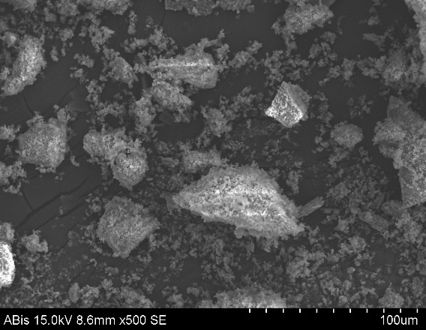 | 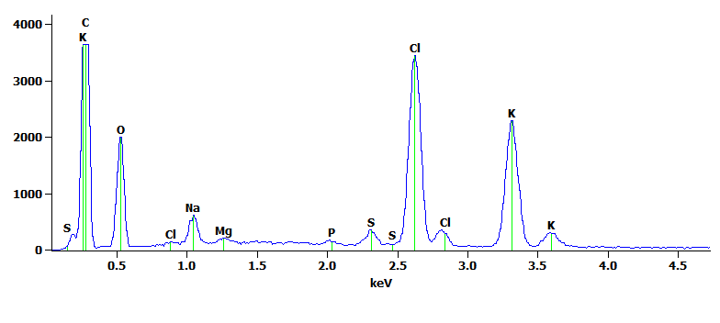
b)
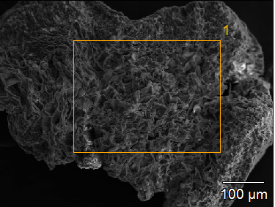 | 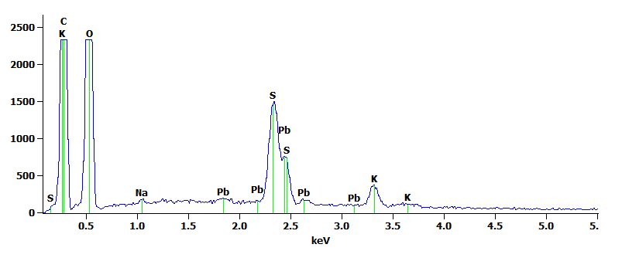
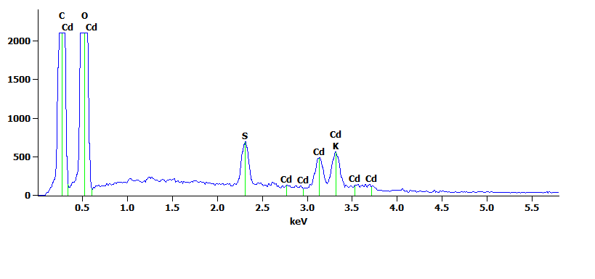
c)
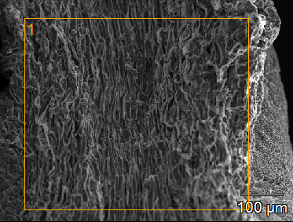
Figure 2: SEM-EDX spectra of the algae Bifurcaria bifurcata (treated): (a) before adsorption; (b) after adsorption of Pb(II); (c) after adsorption of Cd(II).
The EDX spectrum shows that the main components of the Bifurcaria bifurcata wall are carbon, oxygen, sodium, sulfur, potassium, calcium, magnesium, phosphorus and chlorides. The presence of this latter is probably due to the pretreatment of algae by NaCl. Otherwise, all the elements are present in very small quantity except chlorides and potassium.
The EDX analysis of the biosorbent before and after biosorption of the Cd(II) and Pb(II) ions confirms observations on the SEM (b & c) images. Indeed, it is clear that the peaks of the two Cd(II) and Pb(II) ions were observed when Bifurcaria bifurcata was exposed to these solutions of Cd(II) and Pb(II). Some elements initially present on the walls of the matrix have been replaced by the Cd(II) and Pb(II) ions which corroborates [18]results.

3.2. Influence of pH
It is well known that the pH of an aqueous solution affects the solubility of the metal and the concentration of the counter ions attached to the functional group of the biosorbent are the carboxylic, hydroxylic and sulfonates groups [19] .Therefore pH can be considered as one of the most important parameters that could affect the biosorption of metal ions in solution [20-21].
Figure 3 shows effects exerted by solution pH ranged from 1 to 10 (by addition of NaOH or HCl) on biosorption process of Cd(II) and Pb(II) ions by Bifurcaria bifurcata. The obtained results showed that the maximum biosorption of Cd(II) and Pb(II) reached 48.54mg.g⁻¹ and 53.64 mg.g⁻¹ at pH 5.5, respectively. Therefore, all the experiments were carried out at pH 5.5.
Figure 3: Effect of pH on adsorption of Cd(II) and Pb(II) by Bifurcaria bifurcate; Mass of the adsorbent = 0.1g; Volume of the solution = 50ml; Concentration =100mg.l⁻¹; Time=60 min ; Temperature = 298 K.

3.3. Effect of biomass quantity
The amount of the biosorbent has a great influence on the process of biosorption of the metal ions at a specified initial concentration. The effect on the removal of Cd(II) and Pb(II) ions is studied using different masses in the range of 0.01 to 1.4 g and the results are shown in figure 4. It clearly indicates that the adsorption of the studied heavy metals is directly proportional to the quantity of biomass in the range below 0.1 g. The maximum adsorption was obtained at 0.1 g. For higher masse values, adsorption becomes inversely proportional to the quantity of biomass.
Figure 4: Effect of the dose of biosorbent on adsorption of Cd(II) and Pb(II) by Bifurcaria bifurcate; pH = 5.5 ; Volume of solution = 50 ml; Concentration = 100 mg.l⁻¹; Time = 60 min; Temperature = 298 K.
As expected, this is quite consistent with an increase in the number of active sites and the area available. On the other hand, beyond this maximum, the biosorption capacity of metals decreases with the increase in the biomass dose from 0.1 to 0.6 g. An increase in the concentration of biomass causes a decrease for metal adsorbed on a unit mass of algae. Indeed, as long as the amount of adsorbent added to the solution is low, the ions can easily access the adsorption sites. The addition of adsorbents makes it possible to increase the number of adsorption sites, but at the same time the ions of Cd(II) and Pb(II) have more difficulty in approaching these sites because of the bulkiness. Furthermore, a large amount of adsorbent creates aggregates of particles, resulting in a reduction in the total adsorption area and consequently a decrease in the amount of adsorbate per unit mass of adsorbent. Similar trends have been reported in the literature [9-15-22]. In this context, the maximum biosorption of Cd(II) and Pb(II) using different masses of algae Bifurcaria bifurcata was measured at 0.1 g. All these data are of great importance since they allowed us to optimize the biosorption of the two heavy metals. Therefore, in the rest of our studies, the optimal quantity of 0.1 g of adsorbent per 50 ml of solution will be used.

3.4. Initial concentration effect
Bifurcaria bifurcata biosorption capacity as a function of initial Cd(II) and Pb(II) concentrations was studied at different concentrations in the range of 10 mg.l⁻¹ to 1500 mg.l⁻¹. Figure 5 indicates that the sorption capacity of the metal increases with the increase of the initial concentration of the metal ions. This is due to an increase in the initial concentration of ions providing a greater motive force to overcome all mass transfer resistances between the solid phase and the aqueous phase resulting in higher adsorption of metal ions [15-23-24]. Then an equilibrium plateau value appears when the initial concentration exceeds 500 and 1000 mg.l⁻¹ respectively for Cadmium and Lead. This plateau can result in the saturation of the active sites involved in the adsorption process.
Figure 5: Effect of the initial concentration on adsorption of Cd(II) and Pb(II) by Bifurcaria bifurcate; Mass of adsorbent = 0.1 g; Volume of solution = 50 ml; PH = 5.5; Time = 60 min; Temperature = 298 K.

3.5. Influence of contact time
Contact time is one of the important parameters for a successful application of biosorption. Adsorption tests were carried out with a solution carrying a concentration of 10, 100 and 400 mg.l⁻¹ of Cd(II) and Pb(II) at 25 ° C and pH = 5.5. Figure 6 shows the biosorption of the Cd (II) and Pb (II) ions by the algae Bifurcaria bifurcata as a function of the contact time.
As might be expected, the analysis of figure 6 clearly shows the enhancement of biosorption efficiency with the increase in contact time and then stabilizes. Indeed, the retention rate increases with increasing reaction time by following two different behaviours. The first indicate that the reaction rate of each heavy metal adsorbed increase rapidly with the contact time up to 30 min. After this faster step, the biosorption rate becomes slower and final no further significant biosorptionis noted beyond 60min. Therefore the optimal contact time of 60 minutes was chosen for biosorption tests.
Figure6: Effect of contact time on adsorption of Cd(II) and Pb(II) by Bifurcaria bifurcata.
Mass of adsorbent = 0.1 g; Volume of solution = 50 ml; PH = 5.5; Temperature = 298 K; Time = 0-100 min.

3.6. The adsorption kinetics
The kinetic study provides valuable information for the adsorption mechanism and the control of the biosorption process phenomena such as mass transfer or chemical reaction leading to the determination of the optimal conditions for batch processes at industrial scales [24]. In discontinuous systems, adsorption kinetics are described by a number of models based on the adsorption equilibrium such as the external diffusion model on a homogeneous surface, the intraparticle diffusion model and the reaction models of surface. Linearized kinetic models take the following forms (Table 1):

Table 1: Lists of kinetic equations used.
model | Nonlinear expression | Linear expression | reference
External diffusion | $$-\frac{dC_{t}}{dt}=k\left(\frac{a}{v}\right).\left(C_{t}-C_{e}\right)$$ | $$\ln\left[\frac{\left(C_{0}-C_{e}\right)}{\left(C_{t}-C_{e}\right)}\right]=Kt$$ | [15-25]
intra-particle diffusion | $$q_{t}=k_{D}t^{1/2}+C_{D}$$ | $$q_{t}=k_{D}t^{1/2}+C_{D}$$ | [15-25]
pseudo-premier order | $$+\frac{dq_{t}}{dt}=k_{1app}.(q_{e}-q_{t})$$ | $$\ln\left(q_{e}-q_{t}\right)=\ln\left(q_{e}\right)-k_{1app}.t$$ | [26-27]
pseudo-second order | $$+\frac{dq_{t}}{dt}=k_{2app}{(q_{e}-q_{t})}^{2}$$ | $$\frac{t}{q_{t}}=\frac{1}{K_{2}{.q}_{e}^{2}}+\frac{1}{q_{e}}t$$ | [28-29]

Based on experimental data and kinetic model parameters, it appears that the amount adsorbed for Cd (II) and Pb (II) at equilibrium (qe) increases exponentially with increasing initial concentration. The most relevant result of the modeling of the adsorption kinetics concerns the good fit of the pseudo-second order model. This is confirmed by the low statistical error values obtained (See Tables 2a and 2b). Thus. the values of the correlation coefficient R² obtained with the model of the pseudo-second order are very high and greater than 0.99.
Moreover. the RMSE and χ² values are very low in comparison to other kinetic models (pseudo-first order. external diffusion. intra-particle diffusion). The experimental value of qe agrees very well with that predicted by the pseudo-second order kinetic model. Similar experimental results indicate that the pseudo-second order kinetic model corresponds to equilibrium data for the sorption of heavy metal ions on algal biomass in aqueous solutions [30].

Table 2a: Parameters of the external diffusion model and the intraparticle diffusion model of kinetics adsorption of Cd(II) and Pb(II) by Bifurcaria bifurcata.

 | The external diffusion model |  |  |  | The intra-particle diffusion model
C₀  (mg.l⁻¹) | k | R² | RMSE | $$2$$ | k_{d}  (mg.g^{-1.}min^{-0,5}) | C | R² | RMSE | χ²
Cd(II)
10 | 0.3977 | 0.8874 | 5.4773 | 2.7461 | 0.5994 | 0.5128 | 0.9034 | 0.7580 | 2.4163
100 | 0.0637 | 0.9976 | 0.0836 | 0.0414 | 5.9055 | 4.2821 | 0.9304 | 6.1973 | 17.7818
400 | 0.3571 | 0.9810 | 0.2155 | 0.2811 | 3.7704 | 34.62 | 0.8623 | 5.8989 | 9.5923
Pb(II)
10 | 0.0656 | 0.9842 | 0.2711 | 0.4126 | 0.4665 | 0.3268 | 0.9126 | 0.5656 | 1.2806
100 | 0.0821 | 0.9630 | 0.4844 | 12.0811 | 6.1324 | 6.072 | 0.9575 | 4.7420 | 7.5818
400 | 0.0981 | 0.9505 | 0.2155 | 0.2811 | 19.4818 | 16.392 | 0.9559 | 5.8989 | 9.5923

Table 2b: Parameters of the surface reaction models of kinetics adsorption of Cd(II) and Pb(II) by Bifurcaria bifurcata.

Pseudo-first order |  |  |  |  |  | Pseudo-second order
C₀  (mg.l⁻¹) | k₁  (min⁻¹) | q_{e}  (mg .g⁻¹) | R² | RMSE | $χ$² | k₂  (g.mg⁻¹.min⁻¹) | q_{e}  (mg.g⁻¹) | R² | RMSE | $χ$²
Cd(II)
10 | 0.1242 | 10.4 | 0.9545 | 0.7420 | 1.7507 | 0.0610 | 6.5 | 0.9869 | 0.7669 | 0.9868
100 | 0.0474 | 43.6 | 0.9645 | 0.1741 | 0.1597 | 6.7E-05 | 64.9 | 0.9897 | 0.0677 | 0.1220
400 | 0.2962 | 52.2 | 0.9963 | 0.2155 | 0.2393 | 1.1E-05 | 66.7 | 0.9998 | 0.0077 | 0.0012
Pb(II)
10 | 0.0656 | 3.8 | 0.9842 | 0.2711 | 0.7853 | 0.0733 | 5.1 | 0.9930 | 0.3112 | 0.2067
100 | 0.0617 | 50.9 | 0.9960 | 0.1795 | 0.5424 | 4.9E-05 | 64.5 | 0.9999 | 0.0173 | 0.0033
400 | 0.0070 | 175.6 | 0.9769 | 3.7855 | 1.42039 | 1.8E-06 | 199.6 | 0.9935 | 0.0151 | 0.0232

3.7. Adsorption isotherm
The adsorption of one substance from one phase to another's surface in a specific system leads to a thermodynamic distribution between phases when the system reaches equilibrium. This distribution can be expressed in terms of adsorption isotherms [31].
The biosorption isotherms are characterized by defined parameters. the values of which express the surface properties and the affinity of the biosorbent for different metal ions. In this study, two isothermal models were selected to adapt to experimental data, namely Langmuir and Freundlich. It is interesting to note that the empirical model of Freundlich is used to describe heterogeneous adsorption whereas the Langmuir model suggests that the adsorption of molecules takes place on a homogeneous monolayer surface without interaction between the adsorbed molecules [32-33]. The mathematical expressions of these two isothermal models are summarized in Table 3.

Table 3: List of adsorption isotherms.

Model | nonlinear expression | Linear expression | Reference
Langmuir | $$q_{e}=\frac{q_{m,L}*K_{L}*C_{e}}{1+K_{L}*C_{e}}$$ | $$\frac{1}{q_{e}}=\frac{1}{q_{m,L}*K_{L}}\frac{1}{C_{e}}+\frac{1}{q_{m,L}}$$ | [28-33]
Freundlich | $$q_{e}=K_{F}*C_{e}^{n}$$ | $$Lnq_{e}=LnK_{F}+nLnC_{e}$$ | [28-32]

The Langmiur and Freundlich isotherm plot for the biosorption of Cd and Pb onto Bifurcaria bifurcata biomass (Figure 8 and 9 ) , the values of correlation coefficients R² mean square error (RMSE) and test χ² show that the experimental biosorption data of the heavy metals studied are represented by the Langmuir model. which suggests the formation of a monolayer of Heavy metal ions on the outer surface of the biosorbent. The maximum biosorption capacity for Cadmium and Lead are 71 and 277.77 mg.g⁻¹ respectively (see figure7).
The Freundlich model is used to describe adsorption on a heterogeneous surface. The values of n suggest the heterogeneity of the surface of the biosorbent and indicate a favorable biosorption of the Pb (II) and Cd(II) ions on the biomass of brown algae. However, the values of the correlation coefficients (R²) obtained in the Freundlich model are lower than those obtained for the Langmuir model (Table 4). Therefor the Freundlich model is not adequate to describe the biosorption process of Pb(II) and Cd(II) on algal biomass in comparison to the Langmuir model. Such result corroborates [34] findings and give evidence that the adsorption isotherm corresponds to the L-type pattern and is very well fitted using Langmuir model.

Figure 7: Isotherm adsorption of Cd(II) and Pb(II) by Bifurcaria bifurcata.
Mass of adsorbent = 0.1 g; Volume of solution = 50 ml; Time = 60 min; PH = 5.5; Temperature = 298 ° C.

Table 4: Parameters of isotherm adsorption of Cd(II) and Pb(II) by Bifurcaria bifurcata.
Element | Langmuir model |  |  |  |  |  | Freundlich model
 | q_{m}  mg.g⁻ | K_{L}  (l.mg⁻¹) | R_{L} | R² | RMSE | 2 | K_{F}  mg^{(1-n).}l^{n}.g⁻¹ | n | R² | RMSE | 2
Cd | 71.2 | 0.1 | 0.075 | 0.9997 | 0,0015 | 7.6E-4 | 11 | 0 .3194 | 0.9270 | 0.4241 | 0.3149
Pb | 277.7 | 0.0506 | 0.157 | 0.9998 | 0,0071 | 8.9E-4 | 17.4144 | 0.4750 | 0.9290 | 0.6655 | 0.6104

Figure 8: Langmuir isotherm for Cd and Pb biosorption onto Bifurcaria bifurcata biomass.

Figure 9: Freundlich isotherm for Cd and Pb biosorption onto Bifurcaria bifurcata biomass.

Conclusion
In this work, the use of an adsorbent prepared from the algae Bifurcaria bifurcata for the removal of the Cd(II) and Pb(II) ions from the aqueous solutions was studied. The effect of several parameters such as pH, contact time and initial concentration of metal ions on adsorption were determined. The results show that the adsorption phenomenon increases with the increase of the initial concentration of the metal ions. The optimum pH for the adsorption was determined and is equal to 5.5. The ion elimination kinetics indicate an optimal contact time of 60 min. The kinetic modelling of the adsorption of Cd(II) and Pb(II) ions was carried out using the pseudo-first order, pseudo-second order and intra-particle diffusion models. Kinetic models have been evaluated using linear regression and the pseudo-second order model better describes kinetics than the order 1 model. Equilibrium sorption studies of the Cd(II) and Pb(II) ions were modelled using the Langmuir and Freundlich isotherms using a linear optimization approach and the experimental data were better described by the Langmuir model. This indicates that the monolayer adsorption capacity of Cadmium is 72 mg.g⁻¹ and 277.77 mg.g⁻¹ for Lead, which implies that the adsorbent is effective for removal of Cd(II) and Pb(II) in an aqueous system. These results highlight the potential for the use of the algae Bifurcaria bifurcata as an adsorbent for the removal of Cd(II) and Pb(II) ions.

Acknowledgement: The authors gratefully acknowledge the CUR CA2D of Chouaïb Doukkali University (El Jadida-Morocco) for its support.

References
- B.D. Carson, H.V Ellis, J.L. Mc Cann, Lewis Publication. Chelsea. Michigan, 17 (1986) 133.
- B.D. Honeyman, P.H. Santsch, Environ. Sci. Technol. 22 (1988) 862.
- F. Barbier, G. Duc, Colloids Surf. Physicochem. Eng. Aspects .166 (2000) 153–159.
- A. Sari, M. Tuzen, J Hazard Mater. 157 (2008) 448–454.
- A. Sarı, M. Tuzen, M. Soylak, J. Hazard. Mater. 144 (2007)41–46.
- S. Hajialigol, M.A. Taher, Adsorpt. Sci. Technol. 24 (2006)487–496.
- A.R. Turker, Sep Purif Rev. 41(2012)169–206.
- Q. Yu, J.T. Matheickal, P. Yin, P. Kaewsarn, Water Res. 33 (1999) 1534–1537.
- A. Sari, M. Tuzen, J Hazard Mater. 152 (2008) 302–308.
- A. Iyer, K. Mody, Mar Pollut Bull. 50 (2005) 340–343.
- Y. Goksungur, S. Uren, U. Guvenc, Bioresour Technol. 96 (2005) 103–109.
- R.A. Anayurt, A. Sari, M. Tuzen, Chem Eng J. 151 (2009) 255–261.
- S. Tunali, T. Akar, A.S. Ozcan, I. Kiran, A. Ozcan, Sep Purif Technol. 47 (2006) 105–112.
- V.K. Gupta, A. Rastogi, Colloids Surf B: Biointerf. 64 (2008) 170–178.
- N. Benzidia, A. Salhi, S. Bakkas, L. Khamliche, Mediterranean Journal of Chemistry. 4 (2015)85-92.
- M. Montazer-Rahmati, P. Rabbani, A. Abdolali, J. Hazard. Mater. 185 (2011) 401–407.
- E.D. Asuquo, A.D. Martin, J. Environ. Chem. Eng. 4 (2016) 4207–4228.
- A. Verma, S. Kumar, S. Kumar, J. Environ. Chem. Eng. 10 (2016) 26.
- E. Fourest, B. Volesky, Environ. Sci. Technol. 30 (1996) 277-282;
- A. Al-Homaidan, J. Alabdullatif, A. Al-Hazzani, A.A. Al-Ghanayem, A.F. Alabbad, J. Biol. Sci. 22 (2015) 795–800.
- M.M. Areco, S. Hanela, J. Duran, M. dos Santos Afonso, J. Hazard. Mater. 213–214 (2012) 123–132.
- M. Wael, Journal of Hazardous Materials .192 (2011) 1827– 1835.
- Z. Chen, W. Ma, J. Hazard.Mater. 155 (2008) 327–333
- N. Nasuha, B.H. Hameed, J. Hazard. Mater. 175 (2010) 126–132.
- B. Alyuz, S. Veli, J. Hazard. Mater. 167 (2009) 482–488.
- G. Blanchard, M. Maunaye, M. Martin, Water Res. 18 (1984) 1501–1507.
- Y. Ho, G. McKay, Process Biochem. 34 (1999) 451–465.
- A. Ioannis Anastopoulos, B. Amit Bhatnagar, Journal of Molecular Liquids. 221 (2016) 954–962
- S. Lagergren, Handlingar . 24 (1898) 1–39.
- A. Azza, N. Ammar, A. Hany, Journal of Advanced Research. 4 (2013) 367–374.
- P. Lodeiro, B. Cordero, J.I. Barriada, Bioresource Technology. 96 (2005) 1796–1803.
- H. Freundlich , J. Phys. Chem. 57 (1906) 385–470.
- I. Langmuir, J.Am. Chem. Soc. 40 (1918) 1361–1403.
- A. Edidiong, M. Alastair, Journal of Environmental Chemical Engineering. 4 (2016) 4207–4228.

(2017) ; http://www.jmaterenvironsci.com

