|  |  |  |
| --- | --- | --- |
| C:\Users\hp-pro\Downloads\tompon_jmes1.jpg | **J. Mater. Environ. Sci., 2025, Volume 16, Issue 5, Page 814-826**  <http://www.jmaterenvironsci.com> | **Journal of Materials and**  **Environmental Science**  **ISSN : 2028-2508**  **e-ISSN : 2737-890X**  **CODEN : JMESCN**  **Copyright © 2025,**  **University of Mohammed Premier**  **Oujda Morocco** |

**Green Synthesis and Characterization of Tungsten Oxide Nanoparticles Using *Cassia fistula* Leaf Extract**

**Daniel Jildawa1 \*, Iliya I. Nkafamiya2, S.A. Osemeahon2, J. M. Yelwa2**

*1Department of Chemical Science Technology, Federal Polytechnic Mubi, P.M.B.35, Nigeria*

*2Department of Chemistry, Modibbo Adama University, P. M. B. 2076, Yola, Nigeria*

*2Department of Scientific and Industrial Research, National Research Institute for Chemical Technology, P. M. B. 1052, Zaria, Nigeria*

*\*Corresponding author, Email address:* [*danieljildawa@gmail.com*](mailto:danieljildawa@gmail.com)

|  |  |
| --- | --- |
| **Received** 20 Mar 2025, **Revised** 22 Apr 2025, **Accepted** 23 Apr 2025  **Keywords:**   * *Green synthesis;* * *Cassia fistula;* * *Tungsten oxide nanoparticles;* * *Phytochemical Screening;* * *Biosynthesis;* * *Nanotechnology*   ***Citation****: Daniel Jildawa., I.I. Nkafamiya, S.A, Osemeahon,. J. M. Yelwa (2025) Green synthesis and characterisation of tungsten oxide nanoparticles using cassia fistula leaf extract, J. Mater. Environ. Sci., 16(5), 814-826.* | **Abstract:** Nanotechnology has accelerated metal oxide nanoparticle advancements in industrial, biomedical, and environmental applications. Conventional synthesis techniques have environmental concerns due to toxic reagents and high energy consumption. This paper reports first a bibliometric analysis using VOS viewer based on the Scopus data on the nanoparticles and natural plants and thereafter we exposed the green synthesis of tungsten oxide nanoparticles (WO₃ NPs) using Cassia fistula leaf extract as a green reducing and stabilizing agent. The nanoparticles were characterized by FTIR, UV-visible (UV-Vis) spectroscopy, X-ray diffraction (XRD), and scanning electron microscopy (SEM). FTIR established involvement of bioactive compounds in nanoparticle formation with significant shifts in hydroxyl (-OH) and carbonyl (C=O) peaks at 3450-3443 cm⁻¹ and 1631-1626 cm⁻¹, respectively. UV-Vis spectroscopy showed a strong peak at 250-290 nm due to O²⁻ to W⁶⁺ charge transfer transitions with a calculated energy bandgap value of 4.28 eV, indicating low electrical conductivity. XRD showed clearly defined monoclinic WO₃ structure with crystallite dimensions from 33.26 nm to 47.66 nm, confirming formation of highly crystalline nanoparticles. SEM images showed a granular, densely packed morphology, indicating effective stabilization by phytochemicals. These findings confirm eco-friendly potential of Cassia fistula-mediated WO₃ NPs for use in applications such as corrosion inhibition and catalysis and underscore green synthesis in producing stable, functionalized nanoparticles. |

# 1. Introduction

Nanoparticles have gained a lot of interest due to their unique physicochemical properties like high surface area, quantum effects, and optically and electrically tunable properties. These properties make them applicable in medicine, electronics, catalysis, and environmental remediation (Parashar *et al.*, 2020). Nanoparticles can be synthesized using three general categories: physical, chemical, and biological. While physical and chemical processes have traditionally been used in nanoparticle synthesis, they use high energy and toxic chemicals and therefore pose environmental hazards (Kumar *et al.*, 2023).

Green synthesis processes, particularly plant-mediated processes, have provided a green alternative to conventional synthesis processes. Plant extracts, microbes, or biomolecules have been utilized in such processes to reduce metal ions and stabilize nanoparticles (Singh *et al.*, 2020). Besides minimizing toxic byproducts, green synthesis also enhances biocompatibility and thereby provides a viable option for biomedical and environmental applications (Owoeye *et al.*, 2024).

Tungsten oxide nanoparticles (WO₃ NPs) have emerged as a promising material due to their excellent chemical stability, optical properties, and catalytic efficiency. These nanoparticles exhibit remarkable photochromic, electrochromic, and gas-sensing capabilities, making them highly useful in energy storage, sensors, and photocatalytic applications (Aliasghari *et al.*, 2020). Furthermore, WO₃ NPs have shown significant potential in biomedical fields, particularly for anticancer applications, due to their pH-sensitive cytotoxicity and ability to induce reactive oxygen species (Popov *et al.*, 2020).

Electrochromic coatings in energy-efficient windows and energy-saving displays use tungsten oxide. It has been established in studies that electrochromic devices using tungsten oxide have improved charge transfer efficiency and consequently provide more energy savings (Kumar *et al.*, 2023). Tungsten oxide nanoparticles have also been applied in environmental applications such as wastewater treatment and pollution elimination, in which they provide a means to degrade organic pollutants (Aliasghari *et al.*, 2020).

Apart from these applications, recent research highlights WO₃ NPs as a corrosion inhibitor. Through high surface reactivity and strong adsorption, these nanoparticles form a protective coating on metal surfaces, reducing corrosion rates in harsh environments (Raheem & Salman, 2020). Tungsten oxide nanoparticles in anticorrosive coatings have emerged into focus with industries looking for sustainable ways to enhance metal structure lifespan.

Traditional methods for synthesizing tungsten oxide nanoparticles, like sol-gel processing, hydrothermal synthesis, and chemical vapor deposition, involve high temperature, long reaction time, and toxic reagents (Parashar *et al.*, 2020). While effective in controlling particle size and crystallinity, these methods pose environmental risks in terms of generating toxic byproducts and high energy use.

Sol-gel method is the most widely used and it involves acidic or basic conditions, which have environmental hazards and disposal issues (Aliasghari *et al.*, 2020). Hydrothermal and solvothermal processes, although effective in producing highly crystalline nanoparticles, entail high-pressure conditions and longer reaction times and therefore are not very favorable for bulk applications (Kumar *et al.*, 2023).

Moreover, traditional techniques utilize synthetic stabilizers and surfactants, which can be toxic and limit biomedical and environmental applications of the resulting nanoparticles (Singh *et al.*, 2020). It is therefore a matter of immediate concern to explore alternative synthesis pathways that would be friendly to the environment, inexpensive, and scalable.

The bibliometric analysis becomes more introduced to indicate the quantitative and qualitative scientific production of authors, affiliations, countries and the possible collaboration (Abramo & D’Angelo, 2014; Velez-Estevez *et al.*, 2022; N’diyae *et al.*, 2022; Lrhoul *et al.*, 2023; Passas, 2024; Hammouti *et al.*, 2025). The VOS viewer tool is presented by the mapping of the paper’s information, showing authors, co-authors, and countries, by colored nodes. More than 19400 “green synthesis & nanoparticle” articles were collected from Scopus from 2003 to 2025. The increase has been gradually marked over the last decade to attain 3541 articles in 2024 (**Figure 1**). This topic covered numerous domains, including the chemistry area from synthesis to engineering to the various applications in Biochemistry, Pharmacology, Medicine, etc, as shown in **Figure 2**.

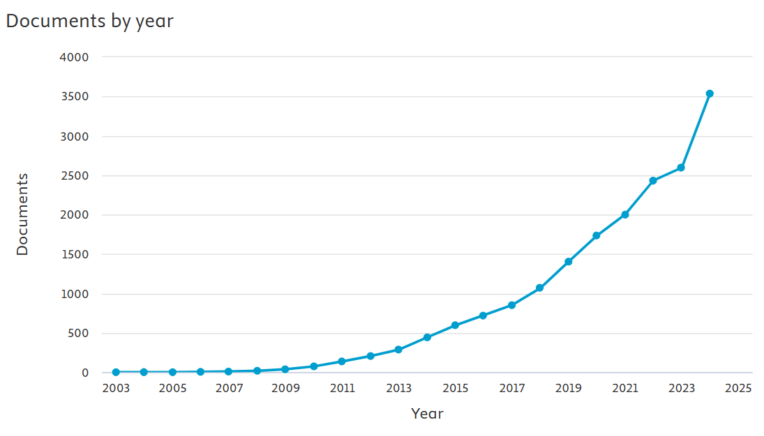

**Figure 1.** Quantitative production on Scopus from 2003 to 2024

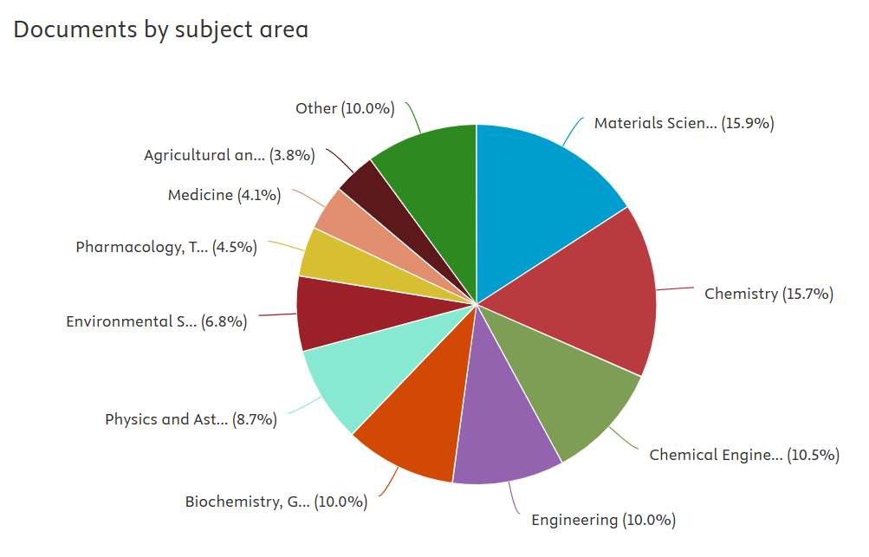

**Figure 2.** Percentage of the Subject area

Going into depth on the performance analysis, **Figure 3** shows that countries with higher productivity hold the visible positions with large size like India, Iran, China, Saudi Arabia, etc, and the links indicate the connection of their authors. The quantitative production can also be shown in **Figure 4**.

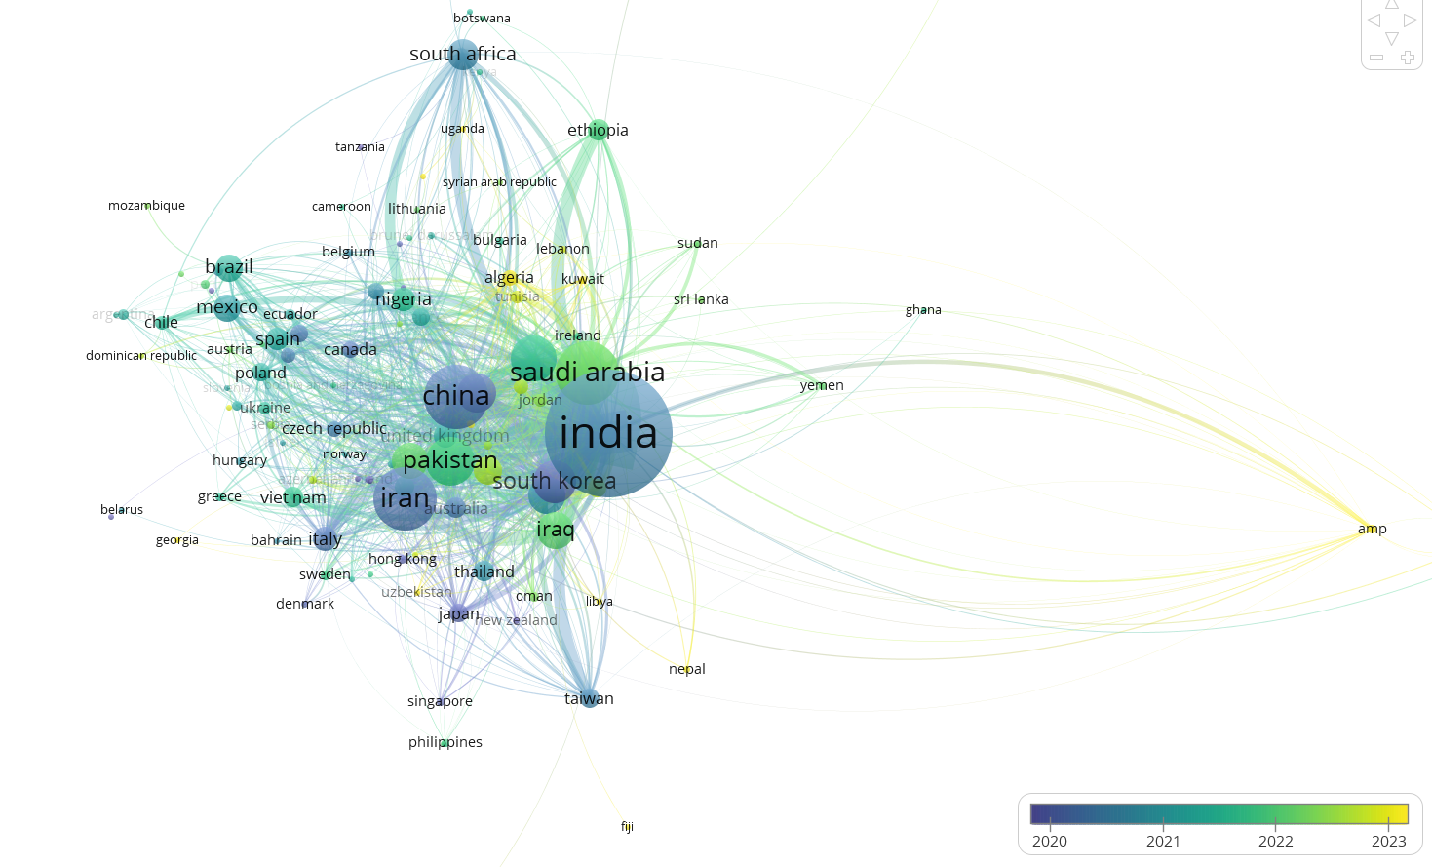

**Figure 3.** List of the top countries on the VOS viewer

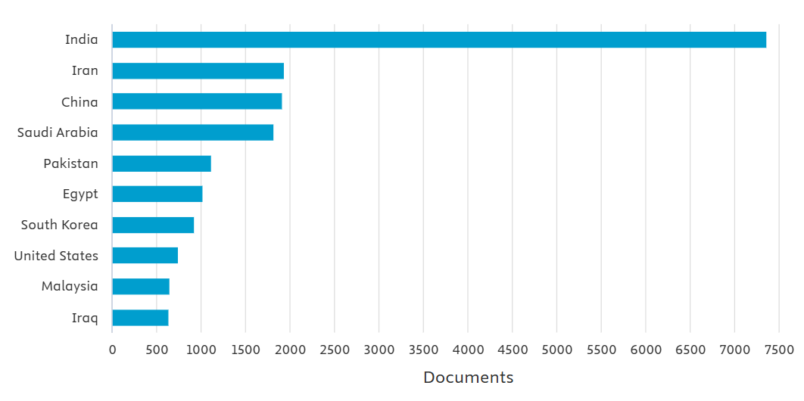

**Figure 4.** List of the top countries interested by “Green synthesis & Nanoparticles”

The science mapping procedure combines two keywords: “green synthesis” and “nanoparticle,” which offers the ranking of the profiler authors, as shown in **Figure 5**. The most published author is Rajeshkumar from India, with up to 120 articles in the studied domain. Their global papers (515) received more than 11,400 citations and an H-index of 49. This large production of Rajeshkumar was explained by the largest node in **Figure 6**.

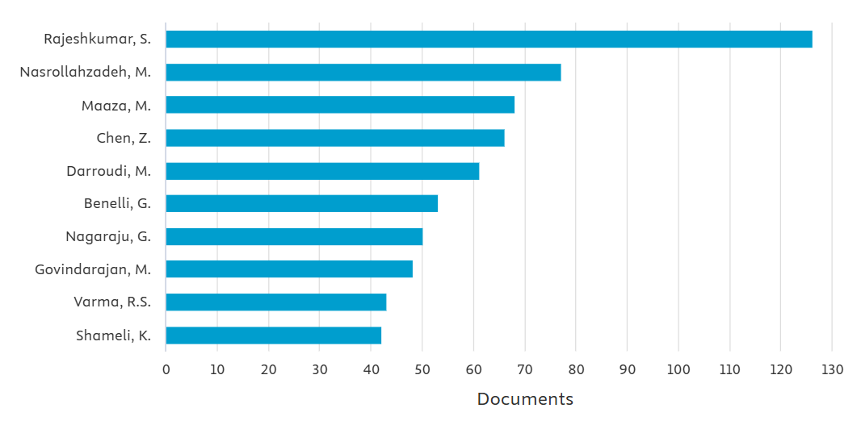

**Figure 5.** Classification of the most published authors

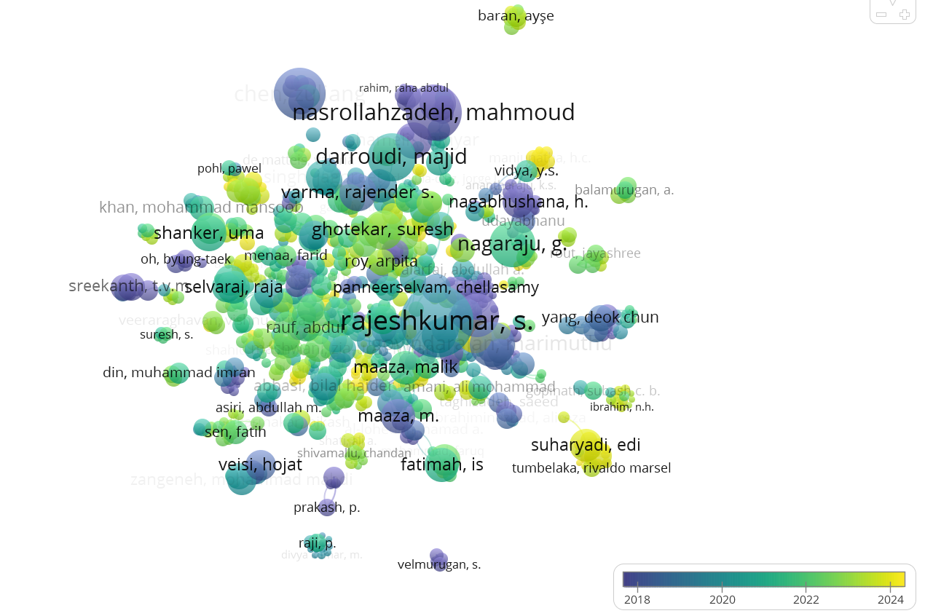

**Figure 6.** Overlay visualisation of the most published authors on the VOS viewer

Among green synthesis techniques, plant-mediated synthesis using *Cassia fistula* has emerged into focus due to rich plant phytochemicals. *Cassia fistula*, golden shower tree, contains bioactive compounds such as flavonoids, tannins, glycosides, terpenoids, and polyphenols that can be used as reducing and stabilizing agents in nanoparticle synthesis naturally (Naseer *et al.*, 2020).

Flavonoids, tannins, glycosides, terpenoids, and polyphenols are the major active compounds in natural plants and play a significant role in biological activities (Taibi *et al.*, 2024; Haddou *et al.*, 2023; Agidew *et al.,* 2022).

*Cassia fistula*'s reducing power is augmented by flavonoids and phenolic compounds present in it, which can transform metal precursors into stable nanoparticles (Veeramani *et al.*, 2022). The plant's phytochemicals also provide a natural capping layer that avoids nanoparticle aggregation and stabilizes them (Abaid *et al.*, 2023). Use of Cassia fistula extract not just eliminates synthetic stabilizers but introduces bioactive functionalities that enhance nanoparticle biocompatibility. More than 1160 articles collected from Scopus on *C. fistula* . Hu Q.F. (China) is the most published author reachin 18 articles. The overlay visualisation shown below specifies that the color depends on the time: violet colour indicates that the research was made around 2013, and yellow one to recent publications.

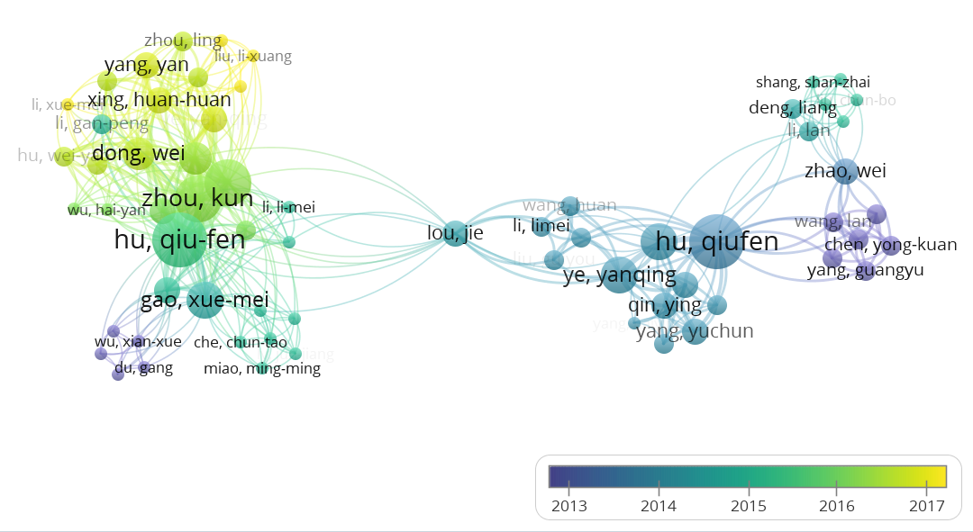

Recent studies have confirmed the efficacy of Cassia fistula-mediated nanoparticles in biomedical and environmental applications. To provide just one example, Cassia fistula-extract-mediated silver nanoparticles have shown high antibacterial and anticancer activity and therefore have tremendous potential in health applications (Danish *et al.*, 2022). Moreover, Cassia fistula-mediated zinc oxide nanoparticles have also been reported to exhibit high antioxidant and antimicrobial activity, confirming the plant's status as a green nanotechnology bioresource with a wide array of applications (Gaikwad *et al.*, 2020).

While there have been vast applications of tungsten oxide nanoparticles, very little research has been conducted using green synthesis with plant extracts like Cassia fistula. Most studies have focused on chemical and physical synthesis routes without taking into consideration environmental sustainability and effects related to these processes (Parashar *et al.*, 2020). Moreover, while Cassia fistula has been widely applied in metal nanoparticle synthesis, very little has been explored in terms of whether it can be utilized to produce tungsten oxide nanoparticles. This study aims to develop a green and eco-friendly method to synthesize tungsten oxide nanoparticles in order to contribute to green nanotechnology. The findings provide valuable information about plant-mediated nanoparticle synthesis and what it implies for industrial and environmental applications.

# 2. Methodology

***2.1 Collection and Preparation of Cassia fistula Leaf Extract***

***Source and Selection of Plant Materials***

Healthy mature trees in a non-polluted atmosphere were chosen to collect fresh Cassia fistula leaves to ensure minimum contamination. The leaves were picked based on their content in terms of phytochemicals, which plays a very important role in nanoparticle biosynthesis. The leaves were washed with deionized water to remove dust and surface contaminants and dried in open air at room temperature for 5-7 days to prevent destruction of bioactive compounds (Danish *et al.*, 2022).

***Preparation of Ethanolic/Aqueous Leaf Extract***

Dried leaves were ground into a fine powder with a mechanical grinder. A specific amount (e.g., 10 g) of powdered leaves was then extracted with ethanol or distilled water in a Soxhlet extractor for 4 to 6 hours at a temperature of 60°C. Plant material in aqueous extraction was boiled in deionized water for a period of 30 minutes and filtered with Whatman No. 1 filter paper. The filtrate was stored at a temperature of 4°C for use in nanoparticle synthesis in the future (Naseer *et al.*, 2020).

**2.2 Phytochemical Screening**

***Identification of Bioactive Compounds***

Cassia fistula leaf extract was also subjected to a screening test for phytochemicals to identify major bioactive compounds involved in reducing and stabilizing nanoparticles. Standard tests for qualitative detection of flavonoids, tannins, alkaloids, proteins, and glycosides were conducted using ferric chloride, Mayer’s reagent, and Wagner’s reagent (Beg *et al.*, 2023).

These bioactive compounds perform a dual role in nanoparticle synthesis by acting as reducing and capping agents, conferring stability and regulation in nanoparticle growth (Kale *et al.*, 2020).

**2.3 Synthesis of Tungsten Oxide Nanoparticles**

***Preparation of Sodium Tungstate Precursor***

Sodium tungstate dihydrate (Na₂WO₄·2H₂O) was used as a precursor to prepare nanoparticles. Sodium tungstate at a concentration of 0.1 M was dissolved in water and mixed with Cassia fistula leaf extract with constant stirring (Owoeye *et al.*, 2024).

Synthesis was carried out at pH value of 8 to enhance nanoparticle formation and temperature of 90°C to enhance reduction and left to proceed for 2 hours with constant stirring rate of 500 rpm (Naseer *et al.*, 2020).

There was a color change from pale yellow to dark brown, indicating successful synthesis of tungsten oxide nanoparticles (Ashraf *et al.*, 2021).

**2.4 Characterization Techniques**

***UV-Vis Spectroscopy: Confirmation of Nanoparticle Formation***

Synthesized nanoparticles were analyzed using a UV-Vis spectrophotometer in a wavelength of 200-800 nm. A common absorption peak in a wavelength of 300-350 nm was shown to confirm the formation of tungsten oxide nanoparticles (Muruganandham *et al.*, 2023).

***Fourier Transform Infrared Spectroscopy (FTIR)***

FTIR analysis was performed to identify what biomolecules were responsible for reducing and capping nanoparticles (Veeramani *et al.*, 2022).

***X-ray diffraction (XRD) refers to a technique***

XRD analysis was carried out using Cu-Kα radiation with a λ value equal to 1.5406 Å to determine the crystalline nature of the nanoparticles. The JCPDS database was utilized to index peaks for WO₃ and to determine a monoclinic or orthorhombic crystal structure (Tariq *et al.*, 2024).

***Scanning Electron Microscopy (SEM)***

SEM images were obtained to study morphology and particle size distribution in the nanoparticles that had been synthesized (Tabrez *et al.*, 2021).

# 3. Results and Discussion

## 3.1 Phytochemical Analysis

Phytochemical screening of Cassia fistula leaf ethanolic extract identified various bioactive compounds necessary for medicinal and application in nanotechnology. The compounds included alkaloids, proteins, tannins, glycosides, flavonoids, terpenoids, and steroids with no saponin present (**Table 1**). The detection of alkaloids was inconsistent using different reagents, with Wagner’s reagent confirming their presence, suggesting selective reactivity by functional groups. Reducing agents such as flavonoids and tannins with high reducing activity provide reducing power in nanoparticle synthesis by acting as electron donors. The proteins and sugars provide capping to prevent nanoparticle aggregation, with steroids and glycosides providing nanoparticle stability. The absence of saponins shows that specific solvents have been used in extraction. The detection of terpenoids, inconsistent in previous reports, may be due to environmental factors and extraction methods. The findings confirm previous reports, confirming Cassia fistula’s bioactive potential. The phytochemicals enhance green synthesis of tungsten oxide nanoparticles by reducing metal ions and stabilizing nanoparticles, confirming eco-friendliness and sustainability in the method.

Recent studies by Naseer *et al.* (2020) identified that Cassia fistula leaf extract contains high amounts of polyphenol and flavonoid content, which has a key role in nanoparticle formation. The study confirmed that these compounds provide stability by preventing nanoparticle aggregation, which corroborates our findings.

**Table 1.** Qualitative phytochemical analysis of *Cassia fistula* aqueous leaf extract

|  |  |
| --- | --- |
| **Phytochemical** | **Results** |
| Alkaloid | + |
| Protein | + |
| Tannin | + |
| Glycosides | + |
| Flavonoid | + |
| Saponin | - |
| Terpenes | + |
| Steroids | + |

## 3.2 UV-Visible spectroscopy analysis

Cassia fistula leaf aqueous extract shows a high peak in UV spectra from 250 to 280 nm because of π-π\* transitions in molecules such as flavonoids, phenol, and tannin (see **Figure 7**). Such biomolecules act as reducing and stabilizing agents in reducing tungsten ions from sodium tungstate (Na₂WO₄) to form tungsten oxide nanoparticles through electron donation (Abaid *et al.*, 2023). Biosynthesized WO₃ NPs have a strong peak in UV spectra in a range from 250 to 290 nm due to O²⁻ to W⁶⁺ charge transfer transitions confirming successful synthesis.



**Figure 7.** UV-visible spectra of tungsten nanoparticle

Absence of peaks beyond 300 nm indicates high purity and low organic impurities. From Tauc's equation and Planck's equation, energy gap was calculated to be 4.28 eV, which indicates low electronic conductivity. Cassia fistula phytochemicals such as flavonoids and tannins enhance nanoparticle stability and dispersity. These findings confirm green synthesis to obtain stable and functionalized WO₃ NPs to be used in photocatalysis and anticorrosive applications.

It can be compared to that of Muruganandham *et al.* (2020) whose results for green-synthesized tungsten oxide nanoparticles ranged from 2.7 to 2.9 eV.

## 3.3 FTIR spectroscopy

Fourier Transform Infrared (FTIR) spectral analysis disclosed major functional groups in Cassia fistula leaf extract and in vitro-synthesized tungsten oxide nanoparticles (WO₃ NPs) established biomolecular involvement in nanoparticle synthesis. The spectra are shown in **Figures 8.** The broad O-H stretching peak at 3450–3443 cm⁻¹ established presence of phenolic compounds, which was reduced in nanoparticle spectra, suggesting involvement in reducing sodium tungstate. Phenolic compounds appeared in reduced intensity in nanoparticle spectra, suggesting involvement in reduction and capping. Carbonyl groups at 1631 cm⁻¹ were shifted to 1626 cm⁻¹, suggesting interactions with tungsten ions to stabilize nanoparticles. Aromatic amines and proteins at 1500–1300 cm⁻¹ were reduced in nanoparticle spectra, suggesting involvement in reduction and capping. Polysaccharide-associated C-O stretching at 1250–1000 cm⁻¹ was in reduced intensity, suggesting involvement in nanoparticle synthesis. The fingerprint region at 800–400 cm⁻¹ disclosed unique W-O bonds, establishing formation of tungsten oxide nanoparticles. The study established Cassia fistula phytochemicals as reducing and capping agents, ensuring nanoparticle stability and validating green and eco-friendly synthesis.

These findings corroborate previous research in which FTIR analysis showed similar functional groups in plant-assisted synthesis of Ag and CuO nanoparticles (Ashraf *et al.* 2021).



**Figure 8.** FTIR spectra of *Cassia fistula* leaf extract and tungsten oxide nanoparticle

## 3.4 Chemistry of biosynthesis of Tungsten nanoparticles

Biosynthesis of tungsten nanoparticles (WNPs) employs a green and ecofriendly approach using plant extracts, microbes, or biomolecules to reduce tungsten ions in a toxic chemical- and high-energy-free environment. Phytochemicals such as flavonoids, phenols, tannins, and alkaloids act as electron donors to reduce W⁶⁺ ions from sodium tungstate (Na₂WO₄) to tungsten oxide nanoparticles by electron transfer. The biomolecules also act as capping agents to stop nanoparticle aggregation and stabilize them. Slightly alkaline pH, moderate temperature, and high levels of bioactive compounds improve nanoparticle yield and uniformity. Cassia fistula extracts can effectively produce functionalized tungsten nanoparticles for use in corrosion inhibition and catalysis (see **Scheme 1**).



**Scheme 1.** Mechanism for the bio-reduction

## 3.5 Xray diffraction analysis

X-ray diffraction analysis of Cassia fistula extract-synthesized tungsten oxide nanoparticles is a critical step in confirming the crystalline structure, phase structure, and average crystallite size of the material. Results in the XRD pattern (**Figure 9**) indicated successful biosynthesis of tungsten oxide (WO₃) nanoparticles with evident crystallographic planes and particle sizes. XRD analysis confirmed successful monoclinic tungsten oxide nanoparticle synthesis with diffraction peaks for typical planes (100, 110, 101, 200, 111, 201, 113, 220) established by JCPDS standards. .

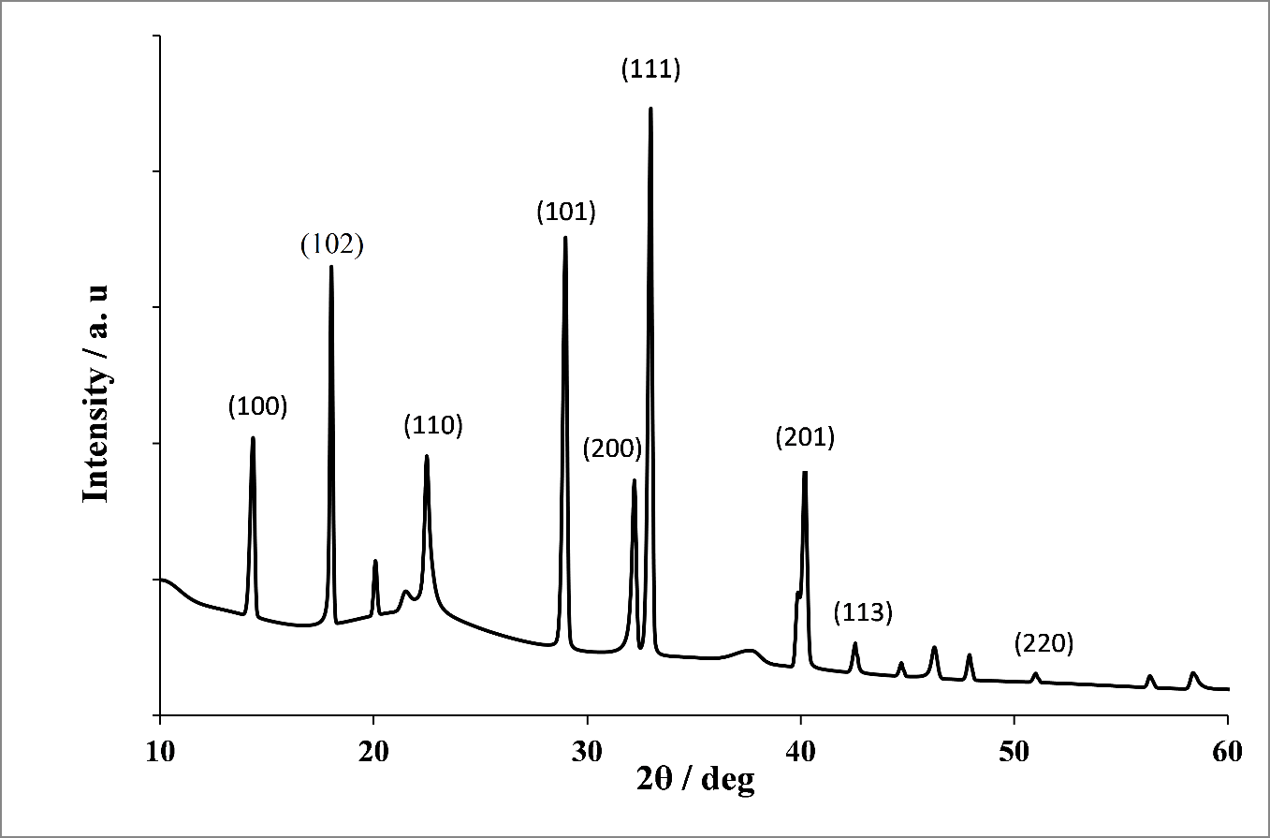

**Figure 9.** XRD pattern of tungsten oxide nanoparticles synthesizedusing *Cassia fistula*

Calculated crystallite sizes by application of the Debye-Scherrer equation ranged from 33.26 to 47.66 nm, with smaller sizes enhancing adsorption and chemical reactivity for anticorrosion inhibition. Cassia fistula extract application ensured high crystallinity and nanometer dimensions, which were comparable or even superior to those in previous studies (Tariq *et al.* 2024). Such structural properties enhance nanoparticle stability and activity in acidic media, which justifies green synthesis efficacy in anticorrosion materials.

## 3.6 Scanning Electron Microscopy

SEM analysis (**Figure 10**) reveals morphology transformation from amorphous sodium tungsten to defined tungsten oxide nanoparticles. The nanoparticles exhibit a close-packed granular morphology, justifying Cassia fistula phytochemical contribution to nanoparticle stabilization and formation. This nanostructured morphology enhances corrosion inhibition and adheres to previous green synthesis reports.

SEM analysis was successful in confirming biosynthesis of tungsten oxide (WO₃) nanoparticles from Cassia fistula leaf extract. Unlike amorphous sodium tungsten, WO₃ nanoparticles had granular, high-surface area, and densely aggregated forms due to reduction and stabilization by phytochemicals. This nanostructured morphology enhances corrosion inhibition due to increased nanoparticle attachment to mild steel surfaces. The findings corroborate previous studies that indicated green synthesis superiority in producing stable, functionalized nanoparticles for industrial applications. The findings corroborate Ihum *et al.* (2024) study, which confirmed that selenium nanoparticles biosynthesized had similar morphological features.

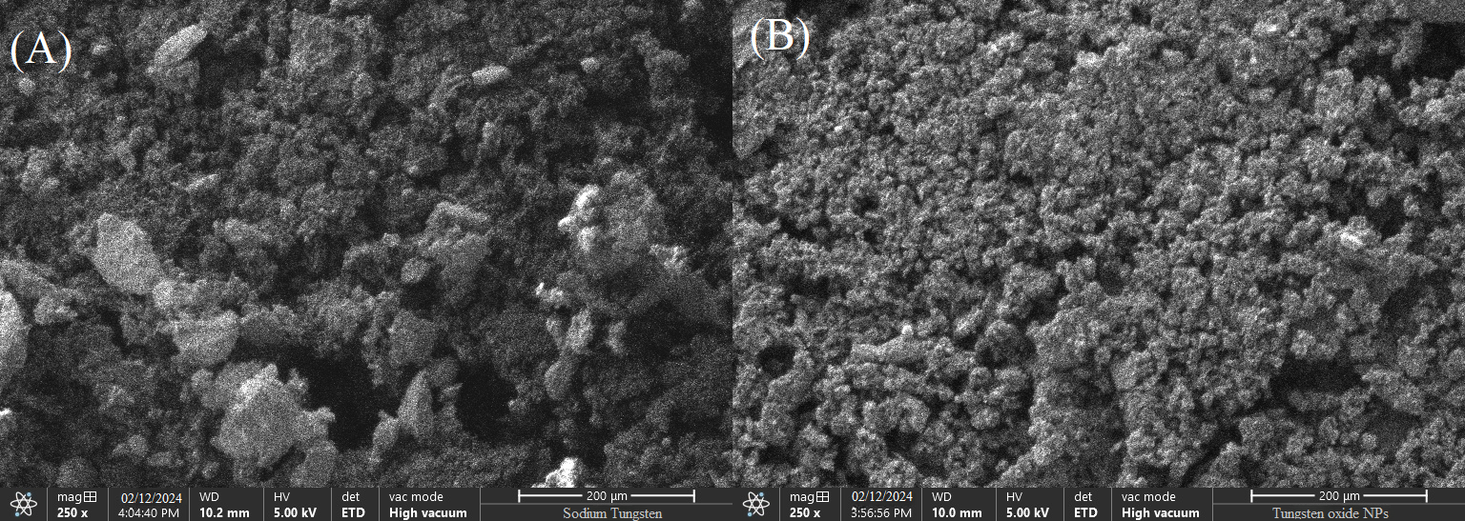

**Figure 10.** SEM micrograph of sodium tungstate (A) and tungsten oxide nanoparticles (B)

# Conclusion

This study successfully established green synthesis of tungsten oxide nanoparticles using Cassia fistula leaf extract and characterized their structural and functional properties using UV-Vis, FTIR, XRD, and SEM. The findings unveil green, low-cost industrial and environmental applications potential for biosynthesized WO₃ NPs, particularly in corrosion inhibition.

# Disclosure statement: *Conflict of Interest:* The authors declare that there are no conflicts of interest.

*Compliance with Ethical Standards:* This article does not contain any studies involving human or animal subjects

# References

Abaid, R., Malik, M., Iqbal, M., Saeed, S., Iqbal, N., Javed, F., & Khan, M. (2023). Biosynthesizing *Cassia fistula* extract-mediated silver nanoparticles for MCF-7 cell lines anti-cancer assay. *ACS Omega, 8*, 17317–17326.

Abramo, G., D’Angelo, C.A. (2014). How do you define and measure research productivity?. Scientometrics 101, 1129–1144, <https://doi.org/10.1007/s11192-014-1269-8>

Agidew, M.G. Phytochemical analysis of some selected traditional medicinal plants in Ethiopia. *Bull Natl Res Cent* 46, 87 (2022). <https://doi.org/10.1186/s42269-022-00770-8>

Aliasghari, H., Arabi, A., & Haratizadeh, H. (2020). A novel approach for solution combustion synthesis of tungsten oxide nanoparticles. *Ceramics International, 46*, 403–414.

Ashraf, H., Anjum, T., Riaz, S., Ahmad, I., Irudayaraj, J., Javed, S., Qaiser, U., & Naseem, S. (2021). Inhibition mechanism of green-synthesized copper oxide nanoparticles from *Cassia fistula* towards *Fusarium oxysporum*. *Environmental Science & Nano, 8*, 1729–1748.

Beg, M., Maji, A., Aktara, M., Kumar, S., Roy, S., Banerjee, A., Saha, B., & Das, P. (2023). Multi-spectroscopic and thermodynamic profiles on HSA binding of *Cassia fistula* leaf-based silver nanoparticles. *Journal of Biomolecular Structure & Dynamics, 1*-13.

Danish, M., Shahid, M., Ahamad, L., Raees, K., & Hatamleh, A. (2022). Nano-pesticidal potential of *Cassia fistula* leaf synthesized silver nanoparticles. *Frontiers in Microbiology, 13*.

Gaikwad, S., Torane, R., & Parthibavarman, M. (2020). *Cassia fistula*–assisted green synthesis, characterization, and their antimicrobial activity of zinc oxide ZnO nanomaterial’s an intracanal microbial agent on oral dental caries. *Nanotechnologies in Russia, 15*, 760–769.

Haddou S., Mounime K., Loukili E. H., Ou-yahia D., *et al*. (2023) Investigating the Biological Activities of Moroccan Cannabis Sativa L Seed Extracts: Antimicrobial, Anti-inflammatory, and Antioxidant Effects with Molecular Docking Analysis, *Mor. J. Chem.,* 11(4), 1116-1136, <https://doi.org/10.48317/IMIST.PRSM/morjchem-v11i04.42100>

Hammouti B., Aichouch I., Kachbou Y., Azzaoui K., Touzani R. (2025) Bibliometric analysis of global research trends on UMI using Scopus database and VOS viewer from 1987–2024, *J. Mater. Environ. Sci.* 16 (4), 548-561

Ihum, T. A., Oledibe, C. F., Kurrah, A. I., & Kayode, E. A. (2024). Inhibitory activity of *Cassia fistula* synthesized selenium nanoparticles against molds of groundnut. *FUDMA Journal of Sciences*, 8(3), 242 - 248. <https://doi.org/10.33003/fjs-2024-0803-2548>

Lrhoul H., Turki H., Hammouti B. (2023), Benammar O., Internationalization of the Moroccan Journal of Chemistry: A bibliometric study, *Heliyon,* 9(5), e15857, ISSN 2405-8440, <https://doi.org/10.1016/j.heliyon.2023.e15857>

Kale, S., Kale, S., & Dandge, P. (2020). Structural identification of antibacterial components isolated from *Cassia fistula*. *International Journal of Herbal Medicine, 8*, 134–142.

Kumar, T., Phogat, P., Sahgal, V., & Jha, R. (2023). Surfactant-mediated modulation of morphology and charge transfer dynamics in tungsten oxide nanoparticles. *Physica Scripta, 98*.

Muruganandham, M., Sivasubramanian, K., Velmurugan, P., Arumugam, N., Almansour, A., Kumar, R. S., Mahalingam, S., & Sivakumar, S. (2023). Phytocrystallization of silver nanoparticles using *Cassia alata* flower extract for effective control of fungal skin pathogens. *Green Processing and Synthesis, 12*.

Naseer, M., Aslam, U., Khalid, B., & Chen, B. (2020). Green route to synthesize zinc oxide nanoparticles using leaf extracts of *Cassia fistula* and *Melia azadarach* and their antibacterial potential. *Scientific Reports, 10*.

N’diaye A.D., Hammouti B., Nandiyanto A. B. D., Al Husaeni D. F. (2022), A review of biomaterial as an adsorbent: From the bibliometric literature review, the definition of dyes and adsorbent, the adsorption phenomena and isotherm models, factors affecting the adsorption process, to the use of Typha species waste as a low-cost adsorbent, *Communications in Science and Technology,* 7 No.1, 140-153

Owoeye, T. F., Bamisaye, A., Eterigho, E., Afolalu, S., Monye, S. I., & Oluwatoyin, O. A. (2024). Eco-friendly synthesis, characterization, and antimicrobial studies of zinc oxide nanoparticles using *Cassia javanica* leaf extract. *2024 International Conference on Science, Engineering and Business for Driving Sustainable Development Goals (SEB4SDG)*, 1–8.

Parashar, M., Shukla, V., & Singh, R. (2020). Metal oxides nanoparticles via sol–gel method: A review on synthesis, characterization, and applications. *Journal of Materials Science: Materials in Electronics, 31*, 3729–3749.

Passas I. (2024). Bibliometric Analysis: The Main Steps. *Encyclopedia.* 4(2), 1014-1025. <https://doi.org/10.3390/encyclopedia4020065>

Popov, A., Han, B., Ermakov, A., Gorshkov, A., Zhukovskaya, E., & Smirnov, V. (2020). PVP-stabilized tungsten oxide nanoparticles: pH-sensitive anti-cancer platform with high cytotoxicity. *Materials Science & Engineering C, 108*, 110494.

Tabrez, S., Rahman, F., Ali, R., Alouffi, A., Alshehri, B., Alshammari, F., Alaidarous, M. A., Banawas, S. S., Bin Dukhyil, A. B., & Rub, A. (2021). Assessment of the antileishmanial potential of *Cassia fistula* leaf extract. *ACS Omega, 6*, 2318–2327.

Taibi M., Elbouzidi A., Haddou M., et al. (2024). Chemical Profiling, Antibacterial Efficacy, and Synergistic Actions of Ptychotis verticillata Duby Essential Oil in Combination with Conventional Antibiotics. *Natural Product Communications.* 19(1). doi:10.1177/1934578X231222785

Tariq, A., Zubair, S., & Ali, M. (2024). XRD analysis of green synthesized tungsten oxide nanoparticles. *Materials Chemistry and Physics*.

Veeramani, C., Newehy, A. S. E., Alsaif, M., & Al-Numair, K. S. (2022). *Cassia fistula* nutrition-rich flower tea-derived biotic nanoparticles synthesis, characterization, and their antioxidant and anti-hyperglycemic properties. *African Health Sciences, 22*(1), 384–394.

Velez-Estevez, A., García-Sánchez, P., Moral-Munoz, J.A. et al. Why do papers from international collaborations get more citations? A bibliometric analysis of Library and Information Science papers. *Scientometrics* 127, 7517–7555 (2022). <https://doi.org/10.1007/s11192-022-04486-4>

(2025) ; <http://www.jmaterenvironsci.com>