 | J. Mater. Environ. Sci., 2023, Volume 14, Issue 6, Page 702-710  http://www.jmaterenvironsci.com | Journal of Materials and  Environmental Science  ISSN : 2028-2508  e-ISSN : 2737-890X  CODEN : JMESCN  Copyright © 2023,  University of Mohammed Premier  Oujda Morocco

Inhibitive Effect of Locally Dioscorea spp Leaf Extracts As a Green Corrosion Inhibitor in Selected Media
B. J. Ifeanyichukwu¹, H. K. Idu^{2*}, N. E. Idenyi³
^{1,3}Department of Industrial Physics, Faculty of Science, Ebonyi state University, Abakaliki, P.M.B.053, Nigeria
²Department of Physics, Taraba State University, jalingo, P. M. B. 1167, Taraba, Nigeria
*Corresponding author, Email address: iduhyacinthkevin@gmail.com.com

Received 07 June 2023, Revised 28 June 2023, Accepted 30 June 2023  Citation: Ifeanyichukwu B. J., Idu H. K., Idenyi N. E. (2023) Inhibitive Effect of Locally Dioscorea spp Leaf Extracts as a Green Corrosion Inhibitor in Selected Media, J. Mater. Environ. Sci., 14(6), 702-710. | Abstract: The aim In this study, we investigated the inhibiting effect of Dioscorea spp leaf extracts on the corrosion of mild steel in selected media using the weight loss method. The mild steel samples were pre-weighed and immersed in NaOH, NaCl and H₂SO₄ solutions respectively containing the leaf extracts, with the control samples immersed in solutions of the media containing no extract. The samples were allowed to stand for 673 hours, with a set of samples from each environment withdrawn at intervals of 168 hours for corrosion deposition. The results obtained from all the media indicate that the corrosion rate decreased as concentrations of Dioscorea spp increased. Results also confirmed that the functioned as an effective and excellent inhibitor in the alkaline, salt and acidic media. Conclusively it was proven that the higher concentration of Dioscorea spp leaf extracts in the media had the best inhibition performance on the mild steel in the selected environments. The results showed that the Dioscorea spp leaf extract is a good candidate in oil and gas industries for the corrosion protection. The microstructure analysis of the various test coupons in the tested media should be carried out in order to reveal the influence of the addition of the leaf extracts to the stimulated media on the grain structure distribution of the mild steel.  Keywords: Mild steel; Media; Corrosion rate; NaOH; NaCl; H₂SO_{4;} Dioscorea spp.

1. Introduction

In recent times, the applications of the new green inhibitors have continued to gain interest in the technological world. In the field of material science and corrosion control, scientists are persistent in seeking better and more efficient ways of combating the corrosion of metals (Idenyi et al., 2015a, Hammouti et al., 1995; Idenyi et al., 2015b ; Idu et al., 2015)
The Corrosive effects are of remarkable consequence in the food processing industry as leaves contain corrosion-aggressive substances, such as tannins, saponins, and flavonoids, etc (Jamiu et al. 2013; Bammou et al. 2010; Bammou et al. 2011), thereby causing a significant impact on the degradation of constructional materials and the maintenance or replacement of products lost or contaminated as a result of corrosion reactions. Corrosion has posed to be more of a nuisance than good (Ji et al. 2015, Kowsari et al., 2014).
The practice of inhibition is commonly used to reduce the corrosive attack on metallic materials. Inhibitors are generally used for this purpose to control metal dissolution. A number of studies have recently appeared in the literature on the corrosion of mild steel in acidic solutions (Al-Amiery et al. 2023; Loukili et al., 2022; Yousefi et al., 2023). The important materials used in the manufacturing sector are mild steel. Mild Steel is widely used in the construction of machine parts that are employed in manufacturing, processing, and production industries (Anyanwu et al. 2014; Anupama et al., 2016; Benali et al., 2013). The best approach to militate corrosion of these structures is to study the corrosive behavior of this metallic material in the environment concerned in order to proffer an appropriate method of protection (Haldhar et al. 2021, Sun et al., 2022). Mild steel corrodes when exposed to air and the oxide formed on it is readily broken down, in the presence of moisture, especially if it is not repaired (Honarvar et al. 2022; Afolabi et al., 2013).
Moreover, since the whole idea of metal protection is anchored on economic gain and environmental sustainability, the substance to be used as a metal corrosion inhibitor must be cheap, readily available, and environmentally friendly. Hence, research activities are geared toward finding a replacement for inorganic metal corrosion inhibitors. The leaf is one of the sources of cheap, readily available, and non-toxic green metal corrosion inhibitors. Leaf Products are organic in nature, and contain certain photochemical substances such as tannins, flavonoids, saponins, organic and amino acids; alkaloids, and pigments that could be extracted by simple less expensive procedures. Extracts from different parts of leaves have been widely reported as effective and good metal corrosion inhibitors in various corrosive media (Marzorati et al. 2019; Ouakki et al. 2022; Berrissoul et al., 2022, Hamed et al., 2021).
Various research works have been carried out in recent times on the use of vegetable extracts as corrosion inhibitors (Ahanotu et al. 2022, Dehghani et al., 2023). The research interest has been necessitated by the fact that the present corrosion inhibitors in the market for the protection of mild steel in the alkaline media are hazardous to the environment and thus compromise safety and sustainability drives (Ghahrenani et al. 2021). There is, therefore, the need to develop inhibitors that are eco-friendly and sustainable. It is, however, noteworthy that the results of these studies show that extracts of the leaf are at the top of the list of non-toxic organic that has been used as corrosion inhibitors to replace environmentally hazardous synthetic. They are non-toxic, environmentally friendly, and readily available. To enhance the efficiency of metal corrosion inhibitors, extensive studies have been undertaken to identify the synergistic effect of other additives. (Rathod et al. 2022, Yee et al., 2020, Hynes et al., 2021) noted that synergism provides a way of improving the inhibitive force of an inhibitor, decreasing the quantity of inhibitor usage, and diversifying the application of the inhibitor in an aggressive environment. The present study is concerned with an investigation of the inhibiting effect of Dioscorea spp leafy extracts on the corrosion of mild steel in selected media by using the weight loss method.

2. Methodology

2.1 Materials
The materials that were used for this study include the following: mild steel rods, hacksaw, lathe machine, electronic weighing balance METTLE TOLEDO model ME204E, beakers (100cm³, measuring cylinder (1000cm³), volumetric flask (250cm³), masking tape, sand paper, nylon thread, hand towel, razor blade, retorts stand, paper sieve, funnel, distilled water, Dioscorea spp leaf extracts. The chemicals that were used were Acetone, tetraoxosulphate (vi) acid (H₂SO₄), sodium hydroxide (NaOH) and sodium chloride (NaCl).

2.2 Material preparation of mild steel and leaf extracts

Mild steel rod was used for this study. The composition of the mild steel rods was analyzed using Optical Emission Spectrometer and the mild steel rods were sourced from metal stockists. The chemicals and reagents that were used in this study were of analytical grade. Cylindrical mild steel samples of diameter 8mm and height of 16mm was machined using lathe machine and hacksaw. Each coupon was degreased by washing in ethanol, dried in acetone and kept in a desiccator and then weight of each coupon was weighed before insert into beaker to obtain the weight difference.

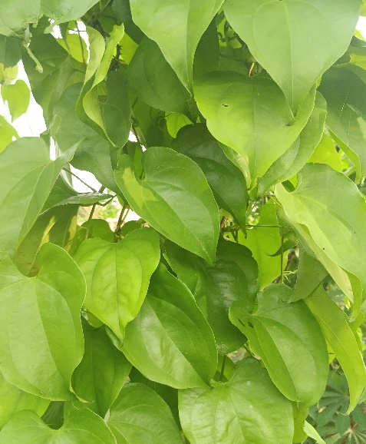
Photo 1: Dioscorea spp leaf

The leaves were collected from Edda-Echara town in Ebonyi State and were identified by laboratory technologist in the Department of Applied Biology, Ebonyi State University, Abakaliki, Nigeria. 20g of leaf extracts of Dioscorea spp was obtained using standard laboratory procedures. Volumetric concentrations of the leaves extracts were expressed in milliliter (ml). Concentrations of Dioscorea spp leaf extracts that was used for the study were 5 cm³, 10 cm³ and 15 cm³ while the concentrations of the acid, alkali and salt were 0.5 M and 1.0 M respectively. A total of twenty (20) beakers were rinsed with distilled water and dried in air before the experimental were set up, so as to avoid additional water. The coupons were immersed in the different media by means of a nylon thread that were hang on a retort stand and tied to the coupons. Samples of the mild steel were inserted into the beakers and allowed to stand for 28 days (672 hours) with a set withdrawn after every 7 days (168 hours). None of the coupons were allowed to touch one another in order to avoid crevice and galvanic corrosion.

2.3 Corrosion characterisation

The sample coupons of mild steel were first weighed using a digital weighing balance, METTLER TOLEDO model ME204E with a least count of 0.0001g, labeled and immersed in the test solutions of acid, alkali and salt with inhibitor. The weight loss of each of the sample coupons were determined and recorded. The determination of weight loss and recording was repeated consistently every 68 hours (7 days) for a period of 672 hours (28 days). Prior to measurement, each coupon was washed in absolute ethanol, rinsed in distilled water, dried in acetone and then weighed (Callister, 2007). The same experiment was repeated in the absence and presence of inhibitor. From the weight loss measurements, the corrosion rate of leaf extracts was calculated using the Eqn. 1.
$Corrosion Rate=\frac{K∆W}{ρAt}$ Eqn.1
where CR is corrosion rate, millimeter per year (mm/yr), K is rate constant equal to 87.6 × 10⁴, $∆W$ is weight loss in mg, is density of material in gcm⁻³ =7.86gcm⁻³, T is exposure time in hours, A is exposed area of coupon in cm².

3. Results and Discussion

3.1 Corrosion rate analysis
Figures 1-6 give the graphical variation of corrosion rate with exposure time as obtained from weight loss measurements. The results obtained for the variation of corrosion rates with exposure time for the mild steel specimens immersed in 0.5 M NaOH with varied concentrations of added Dioscorea spp leaf extract is presented Figure 1. The result obtained show a great value of corrosion rate for the test media without Dioscorea spp leaf extract. The addition of Dioscorea spp extract to the test media resulted in reduction of corrosion rate.
Figure 1. The graph of corrosion rate (mm/yr) against exposure time (hrs) for Dioscorea spp leaf extract in 0.5 M NaOH media. | Figure 2. The graph of corrosion rate (mm/yr) against exposure time (hrs) for Dioscorea spp leaf extract in 1.0 M NaOH media.
Figure 3. The graph of corrosion rate (mm/yr) against exposure time (hrs) for Dioscorea spp leaf extract in 0.5 M NaCl media | Figure 4. The graph of corrosion rate (mm/yr) against exposure time (hrs) for Dioscorea spp leaf extract in 1.0 M NaCl media
Figure 5. The graph of corrosion rate (mm/yr) against exposure time (hrs) for Dioscorea spp leaf extract in  0.5 M H₂SO₄ media | Figure 6. The graph of corrosion rate (mm/yr) against exposure time (hrs) for Dioscorea spp leaf extract in  1.0 M H₂SO₄ media
The difference in corrosion rate for the test media with and without Dioscorea spp extract was much for the 168-hour interval, but from 336 to 672 hours there was a decrease in corrosion rate for the media without Dioscorea spp extract (control experiment). The Dioscorea spp extract shows a good inhibition behavior on the corrosion rate of mild steel in 0.5 M NaOH media. This is an agreement with the findings in the literature (Kowsari et al. 2014, Anyanwu et al., 2014, Rathod et al., 2022).
Figure 2 shows the variation of corrosion rate with exposure time for mild steel immersed in 1.0 M NaOH and addition of different concentrations of Dioscorea spp leaf extract. Corrosion rates were very slow with the three different Dioscorea spp extract concentrations. The control experiment gave higher corrosion rate values throughout the experimental period. These results confirm that plant extract of the Dioscorea spp possesses corrosion inhibiting property. It is not certain, however, whether the optimum concentration needed for more effective corrosion inhibition have been reached with any of the three concentrations used.
The results obtained for the variation of corrosion rate 0.5 M NaOH is presented Figure 3. From the graph, the control experiment has the highest magnitude of corrosion rate because Dioscorea spp extract was not added. The addition of Dioscorea spp extracts to the test medium reduced corrosion significantly throughout the experimental period. The results obtained for the 5, 10 and 15 cm³ respectively Dioscorea spp extract addition to the test medium all similar trend in corrosion rate, indicating that little extract concentration have inhibition effect. The results confirmed the very good effect of the Dioscorea spp extract on the corrosion inhibition of mild steel in 0.5 M NaOH. Figure 4 shows the graph of variation of corrosion rate. The Dioscorea spp extracts addition to the test medium reduced corrosion rate significantly throughout the experimental period compared to the control experiment. The results obtained for the 5, 10 and 15 cm³ respectively Dioscorea spp extract addition to the test medium have close corrosion rate value. The results confirmed the effectiveness of the Dioscorea spp extract on the corrosion rate of mild steel in 1.0 M NaOH media. The extract concentration of 15 cm³ addition appeared to be the best, having a corrosion rate value of 0.00005, 0.00002, 0.00001 and .00001 mm/yr respectively for 168 to 672 hours, respectively, followed by 10 and 5 ml, respectively concentration of Dioscorea spp (Oukkai et al. 2022).
The corrosion rate of the mild steel in the absence of the Dioscorea spp leaf extract and the presence of the Dioscorea spp leaves extract were determined at various concentrations of leaf extract in 0.5 M H₂SO₄ media is shown in Figure 5. From the plot, it can be seen that the normal corrosion profile for passivating metals were noticed. This involves a sharp rise in corrosion rate followed by a gentle decrease as duration time increased. The rate of decrease of corrosion rate was very high in the first seven days of the experiments and then slowed down subsequently. This is as a result of the formation of thin film oxide on the surface of the coupon that acted as barrier between the coupon surface and the media itself. The figure also confirmed that the loss in the corrosion rate of the coupons decreases as the concentration of Dioscorea spp extract increases, indicating good corrosion inhibition performance of leaves extract in the acidic environment. This is in agreement with the findings in the current research (Ahanotu et al. 2022).
Figure 6 is a graph of corrosion rate versus exposure time in the different concentrations of Dioscorea spp extract in 1.0 M H₂SO₄ solution medium just discussed. As expected, the graphs display higher corrosion rates for the coupons subjected in control experiment (without Dioscorea spp extract). As with the Dioscorea spp extract media, the trend of a very high initial corrosion rate which drops very rapidly in the first seven days and then decreased less rapidly afterwards, may be noticed. These graphs also show that in general, the coupons subjected in these media experienced higher corrosion rates as compared to 0.5 M H₂SO₄ media. This result is consistent with the findings of (Idenyi et al. 2015, Helen et al., 2014).
Literature pointed out that Dioscorea species contain a large number of bioactive compounds, such as phenols, flavonoids, saponins, anthocyanins, carotenoids, allantoins, and water-soluble polysaccharides (Lebot et al. 2023, Wang et al., 2023). Recently, it has confirmed that Dioscorea has a variety of pharmacological activities, such as improving the cardiovascular system, and regulating immune function, as well as anti-tumor, anti-bacterial, anti-inflammatory, and anti-diabetic activities (Adomeniene et al. 2022; Ou-yang et al., 2018; Kundu et al., 2021). Phytochemicals derived from Dioscorea, such as polysaccharides, diosgenin, polyphenols, and allantoin – shown below - have been widely used for the treatment of inflammatory and metabolic disorders (Chaniad et al. 2020, Tao et al., 2018).

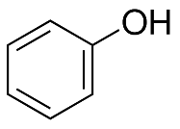  phenols | 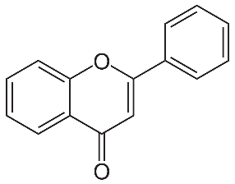  flavonoids | 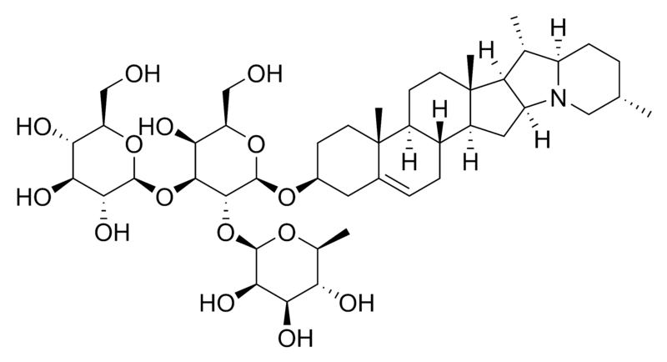  saponins
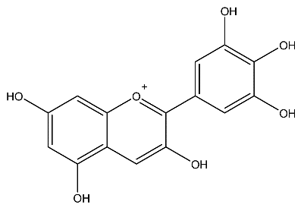  anthocyanins, | 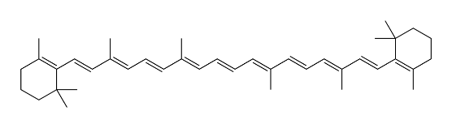  carotenoids | 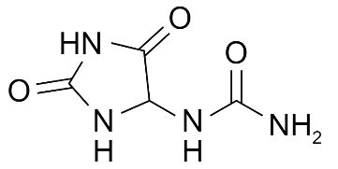  allantoins
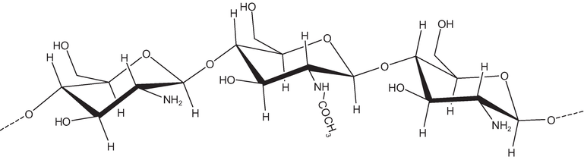
water-soluble polysaccharides
The examination of various molecular structure of these compounds demonstrated the highest inhibitory effect of natural extract because of the presence of heteroatoms (O, N...) as well as aromatic rings and triple / double bonds. Survey of literature shows that the researchers’ unanimated on the synergistic intramolecular effect of the components at different concentrations to create a barrier at the metal surface by competitive or complementary adsorption (Dahmani et al. 2010; Ben Hmamou et al., 2012; Alimohammadi et al., 2023).

Conclusion

In this study, weight loss analysis of leaf extract was used to study the ability of Dioscorea spp leaf extract to retard the corrosion of mild steel in different concentrations of acidic, alkaline and salt environments. The Following conclusions are drawn:
- The results indicated that the corrosion rates of mild steel increased with increasing concentration of leaves extract; at the highest inhibitor concentration of 15 ml, the inhibition efficiency is increased markedly and reached ≥ 92 %.
- Dioscorea spp extracts act as good inhibitor for corrosion of mild steel in both acidic and alkaline environments.
- The corrosion rates of mild steel strongly depend on the concentration of Dioscorea spp leaf extract.
- that the Dioscorea spp leaf extracts act as good green corrosion inhibitor and can be used to retards the corrosion rate of mild steel if the appropriate concentration is used.
- we hope that this leaf extract will be able to replace, the toxic commercial products that are still used by many industries and in the near future.

Acknowledgement : The author is grateful to Prof. N. E. Idenyi and Dr. H. K. Idu from the Department of Industrial Physics, Faculty of Science, Ebonyi State University, Abakaliki, and Taraba State University, Jalingo, Nigeria, respectively for their technical support. The authors acknowledge the contributions of the technical staff of the Centre for Energy Research and Development, Obafemi Awolowo University, Ile-Ife, Osun State, Nigeria, in performing the characterisations.

Disclosure statement: Conflict of Interest: The authors declare that there are no conflicts of interest.
Compliance with Ethical Standards: This article does not contain any studies involving human or animal subjects.

References
Adomėnienė, A.; Venskutonis, P.R. Dioscorea spp.: Comprehensive Review of Antioxidant Properties and Their Relation to Phytochemicals and Health Benefits. Molecules 2022, 27, 2530.
Afolabi A. S., Ngwenya G., Sanusi K. O. and Abdulkareem A. S. (2013). Stress Corrosion Cracking of a Mild Steel in Orange Juice, Proceedings of the World Congress on Engineering 2013 Vol I, WCE 2013, July 3 - 5, 2013, London, U.K
Ahanotu C. C., Madu K. C., Chikwe I. S., Chikwe O. B., (2022) The inhibition behaviour of extracts from Plumeria rubra on the corrosion of low carbon steel in sulphuric acid solution, J. Mater. Environ. Sci., 13(9), 1025-1036
Al-Amiery A.A.; Betti N.; Isahak W.N.R.W.; Al-Azzawi W.K.; Wan Nik W.M.N. (2023) Exploring the Effectiveness of Isatin–Schiff Base as an Environmentally Friendly Corrosion Inhibitor for Mild Steel in Hydrochloric Acid. Lubricants 2023, 11, 211. https://doi.org/10.3390/lubricants11050211
Alimohammadi M., Ghaderi M., Ramazani S.A., A. et al. (2023) Falcaria vulgaris leaves extract as an eco-friendly corrosion inhibitor for mild steel in hydrochloric acid media. Sci. Rep. 13, 3737. https://doi.org/10.1038/s41598-023-30571-6
Anupama K. K., Shainy K. M., Joseph A. (2016) Excellent anticorrosion behavior of ruta graveolens extract (RGE) for mild steel in hydrochloric acid: electro analytical studies on the effect of time temperature and inhibitor concentration, J Bio Tribo Corros, 2, 56-72.
Anyanwu S. I., Eseonu O., Nwosu H. U. (2014) Studies on corrosion characteristics of carbon steel exposed to Na₂CO₃, Na₂SO₄ and NaCl solutions of different concentrations, The International Journal Of Engineering And Science (IJES), 3, 48-60.
Bammou L., Chebli B., Salghi R., Bazzi L., Hammouti B., Mihit M., Idrissi H. (2010). Thermodynamic properties of Thymus satureioides essential oils as corrosion inhibitor of tinplate in 0.5 M HCl: chemical characterization and electrochemical study Green Chemistry Letters and Reviews 3 (3), 173-178
Bammou L., Mihit M., Salghi R., Bazzi L., Bouyanzer A., Al-Deyab S.S., Hammouti B. (2011. Inhibition Effect of Natural Artemisia Oils Towards Tinplate Corrosion in HCl solution: Chemical Characterization and Electrochemical Study, Int. J. Electrochem. Sci., 6 N°5,) 1454-1467
Benali O., Benmehdi H., Hasnaoui O., Selles C., Salghi R. (2013) Green corrosion inhibitor: inhibitive action of tannin extract of chamaerops humilis plant for the corrosion of mild steel in 0.5 M H₂SO₄, J. Mater. Environ. Sci, 4, 127-138.
Ben Hmamou D., Salghi R., Zarrouk A., Messali M., Zarrok H., Errami M., Hammouti B., Bazzi Lh., Chakir A. (2012) Inhibition of steel corrosion in hydrochloric acid solution by chamomile extract, Der Pharma Chim. 4 N°4, 1496-1505
Berrissoul A., Ouarhach A., Benhiba F., Romane A., Guenbour A., Outada H., Dafali A., Zarrouk A. (2022) Exploitation of a new green inhibitor against mild steel corrosion in HCl: Experimental, DFT and MD simulation approach, J. Mol. Liq., 349, 118102.
Callister W. D. (2007) Materials science and engineering, New York, John Wiley and Sons Inc., 579-582.
Chaniad P.; Tewtrakul S.; Sudsai T.; Langyanai S.; Kaewdana K. (2020) Anti-Inflammatory, Wound Healing and Antioxidant Potential of Compounds from Dioscorea bulbifera L. Bulbils. PLoS ONE, 15, e0243632
Dahmani M., Et-Touhami A., Al-Deyab S.S., Hammouti B., Bouyanzer A. (2010), Corrosion inhibition of C38 steel in 1 M HCl: A comparative study of black pepper extract and its isolated piperine, Int. J. Electrochem. Sci., 5 N°8, 1060-1069.
Dehghani A., Ramezanzadeh B. (2023) Rosemary extract inhibitive behavior against mild steel corrosion in tempered 1 M HCl media, Ind. Crops Prod., 193, 116183.
Ghahremani P., Tehrani M. E. H. N., Ramezanzadeh M., Ramezanzadeh B., (2021) Golpar leaves extract application for construction of an efective anti-corrosion flm for superior mild-steel acidic-induced corrosion mitigation at diferent temperatures, Colloids Surf. A Physicochem. Eng. Asp., 629, 127488.
Haldhar R., Prasad D., Bahadur I., Dagadag O., Kaya S., Verma D. K., Seong-Cheol K. (2021) Investigation of plant waste as a renewable biomass source to develop efficient, economical and eco-friendly corrosion inhibitor, J. Mol. Liq. 335, 116184.
Hamed S., Yop K., Verma C., Quraishi M. A., Ebenso E. E. (2021) Challenges and advantages of using plant extract as inhibitors in modern corrosion inhibition systems: Recent advancements, J. Mol. Liq. 321, 114666.
Hammouti B., Aouniti A., Taleb M., Brighli M., Kertit S. (1995). L-Methionine methyl ester hydrochlorid as corrosion inhibitor of iron in 1M HCl, Corrosion, 51 N°6, 411-416.
Haque J., Verma C., Srivastava V., Nik, W. B. W. (2021) Corrosion inhibition of mild steel in 1M HCl using environmentally benign Tevetia peruviana fower extracts. Sustain. Chem. Pharm. 19, 100354.
Helen L.Y.S., Rahim A. A., Saad B., Saleh M. I., Raja P. B. (2014) Aquilaria crassna leaves extracts: A green corrosion inhibitor for mild steel in 1 M HCl medium, Int. J. Electrochem. Sci, 9, 830-846.
Honarvar N. M., Zhang Y., Mahmoodi A., Xu G., Yu J., Wu J., Shi W. (2022) Nanocomposite organic coatings for corrosion protection of metals: A review of recent advances. Prog. Org. Coatings, 162, 106573.
Hynes N. R. J., Selvaraji R. M., Tezeghdenti M., Murugananthan M. A. (2021) Aerva lanata fowers extract as green corrosion inhibitor of low-carbon steel in HCl solution: An in vitro study, Chem. Pap., 75, 1165–1174.
Idenyi N. E., Nwofe P. A., Agbo P. E., Idu H. K. (2015a) Effects of psidium guavaja (guava) and moringa oleifera leaves extract on the corrosion susceptibility of mild steel in an acidic medium, Australian journal of basic and applied sciences, 9, 245-250.
Idenyi N. E., Nwofe P. A., Idu H. K. (2015b) Influence of moringa oleifera and psidium guavaja leaves extract on the corrosion susceptibility of mild steel in an alkaline medium, Journal of applied science research, 11, 158-163.
Idu H. K., Idenyi N. E., Nwofe P. A. (2015) Investigations on the inhibitory properties of moringa oleifera and psidium guajava leaves extract on the corrosion susceptibility of mild steel, Middle-east journal of scientific research, 23, 2862-2867.
Jamiu K. O., Olorunfemi M. A. (2013) Corrosion inhibition of mild steel in acidic medium by jathro phacurcas leaves extract, Journal of electrochemical science and technology, 4, 81-87.
Ji G., Shadma A., Shanthi S., Rajiv P. (2015) Musa paradisica peel extract as green corrosion inhibitor for mild steel in HCl solution, Corrosion Science, 90, 107-117.
Kundu B. B.; Vanni K.; Farheen A.; Jha P.; Pandey D. K.; Kumar, V. (2021) Dioscorea bulbifera L. (Dioscoreaceae): A Review of Its Ethnobotany, Pharmacology and Conservation Needs. South Afr. J. Bot., 140, 365–374.
Kowsari E., Payami M., Amini R., Ramezanzadeh B., Javanbakht M. (2014) Task-specific ionic liquid as a new green inhibitor of mild steel corrosio, Applied Surface Science, 289, 478-486.
Lebot V.; Lawac F.; Legendre L. (2023) The Greater Yam (Dioscorea alata L.): A Review of Its Phytochemical Content and Potential for Processed Products and Biofortification. J. Food Compos. Anal., 115, 104987.
Loukili E. H., Azzaoui K., Author J. O., Author V., Hammouti B. (2022) Corrosion Inhibition using Green Inhibitors: An Overview, Maghr. J. Pure & Appl. Sci., 8(2), 82-93. DOI: https://doi.org/10.48383/IMIST.PRSM/mjpas-v8i1.29392
Marzorati S.; Verotta L.; Trasatti S. P. (2019) Green Corrosion Inhibitors from Natural Sources and Biomass Wastes. Molecules, 24, 48. https://doi.org/10.3390/molecules24010048
Ouakki M., Galai M., Cherkaoui M. (2022) Imidazole derivatives as efficient and potential class of corrosion inhibitors for metals and alloys in aqueous electrolytes: A review. J. Mol. Liq. 345, 117815.
Ou-yang S.; Jiang T.; Zhu L.; Yi T. (2018) Dioscorea nipponica Makino: A Systematic Review on Its Ethnobotany, Phytochemical and Pharmacological Profiles. Chem. Cent. J., 12, 57.
Rathod M. R., Rajappa S. K., Kittur A. A. (2022) Garcinia livingstonei leaves extract infuenced as a mild steel efficient green corrosion inhibitor in 1 M HCl solution, Mater. Today Proc., 54, 786–796.
Rathod M. R., Rajappa S. K., Praveen B. M., Bharath D. K. (2021) Investigation of Dolichandra unguis-cati leaves extract as a corrosion inhibitor for mild steel in acid medium, Curr. Res. Green Sustain. Chem., 4, 100113.
Sun X., Qiang Y., Hou B., Zhu, H., Tian, H. (2022) Cabbage extract as an eco-friendly corrosion inhibitor for X70 steel in hydrochloric acid medium, J. Mol. Liq. 362, 119733.
Tao X.; Yin, L.; Xu, L.; Peng, J. Dioscin: A Diverse Acting Natural Compound with Therapeutic Potential in Metabolic Diseases, Cancer, Inflammation and Infections. Pharmacol. Res. 2018, 137, 259–269.
Wang Z.; Zhao, S.; Tao, S.; Hou, G.; Zhao, F.; Tan, S.; Meng, Q. Dioscorea spp.: Bioactive Compounds and Potential for the Treatment of Inflammatory and Metabolic Diseases. Molecules 2023, 28, 2878. https://doi.org/10.3390/molecules28062878
Yee Y. P., Saud S. N., Hamzah E. (2020) Pomelo peel extract as corrosion inhibitor for steel in simulated seawater and acidic mediums, J. Mater. Eng. Perform., 29, 2202–2215.
Youssefi Y., Ansari A., Ou-ani O., Oucheikh L., Oubair A., Lgaz H., Hammouti B., Chaouiki A., Ko Y.G., Znini M. (2023) Insights into the Corrosion Inhibition Performance of Three 2-Isoxazoline-γ-Lactones for Carbon Steel in Acidic Medium: Linking Molecular and Experimental-Level Information with Microscopic-Scale Modeling. Lubricants.; 11(3):141. https://doi.org/10.3390/lubricants11030141

(2023) ; http://www.jmaterenvironsci.com

