 | J. Mater. Environ. Sci., 2022, Volume 13, Issue 04, Page 461-478  http://www.jmaterenvironsci.com | Journal of Materials and  Environmental Science  ISSN : 2028-2508  e-ISSN : 2737-890X  CODEN : JMESCN  Copyright © 2022,  University of Mohammed Premier  Oujda Morocco

Optimization of Biosorprive Removal of Dichlorvos Removal from Synthetic Wastewater by Acid-Activated Tithonia diversifolia Xylem
O.S. Ojo ^{1,2}, O.O. Agbede¹, O.R. Ogunleye^{,1,2}, V.A. Adeyi^{1,2},
T.J. Afolabi^{1,2}, A.O. Alade^{1,2,3*}
¹Department of Chemical Engineering, Ladoke Akintola University of Technology, Ogbomoso, Nigeria
²Bioenvironmental, Water and Engineering Research Group, (BWERG), Ladoke Akintola University of Technology Ogbomoso, Nigeria
³Science and Engineering Research Group, (SEARG), Ladoke Akintola University of Technology Ogbomoso, Nigeria

Received 04 Jan 2022, Revised 30 Apr 2022, Accepted 30 Apr 2022

Keywords
- Tithonia diversifolia,
- Dichlorvos,
- Biosorption,
- Optimization.
- Isotherm
- Kinetics
- Thermodynamics

aoalade@lautech.edu.ng; Phone: +2347037885961;

Abstract
The study examined the suitability of Activated Tithonia diversifolia xylem (ADFX) as a biosorbent for removal of Dichlorvos. Tithonia diversifolia xylem (TDFX) was activated in an acidic medium before biosorption to increase the surface area. The ADFX before and after biosorption were characterized using Fourier Transform Infrared Spectrometer (FTIR). Biosorption of Dichlorvos was optimized using the D-optimal Design and the factors selected include the contact time (60-120 min), initial concentration of Dichlorvos solution (50-200 mg/L), and the biosorbent dosage (0.2-0.6 g). The optimization studies were analysed using statistical tools included in the Design Expert software. Appropriate isotherm, kinetics, diffusion models, and thermodynamics that best describe the biosorption mechanism were determined. The FTIR spectra show change in absorption peak before and after biosorption. The optimum values obtained for the adsorption capacity and percentage removal are 0.3382 mg/g and 51.04% at 60.07 min contact time, 200 mg/L initial concentration of Dichlorvos solution and 0.20g biosorbent dosage. The process fitted best with Freundlich isotherm (R² = 0.9998), Elovich kinetics model (R² = 0.9730, 0.9454, and 0.8991 at 30, 40, and 50 mg/L initial concentration of the Dichlorvos) while the particle diffusion (Webber-Morris diffusion) was the rate-controlling step. The thermodynamic analysis indicates the process was endothermic with decreasing degree of disorderliness.

.

- Introduction
Organophosphate pesticides including Dichlorvos (2,2-dichlorovinyl dimethyl phosphate), are among the most widely utilized insecticides, especially in agriculture and around 50% of all pesticides developed and used generally belong to this group [1]. The highly intense and common usage of pesticides has resulted in considerable freshwater poisoning by these substances [2,3]. Purifying pesticide-contaminated water has been an essential environmental exercise [4]. Conventional water purification methods, however, cannot remove many of these organic chemicals [5]. There are several approaches to eliminating pesticides from aqueous solutions, including oxidation [6] Photocatalysis [7,8], electrochemical, and adsorption [9]. Biosorption is a physicochemical mechanism through which biological materials are used to adsorb unwanted molecules (pollutants) in a solution. The process has several advantages such as being widely available in nature, inexpensive, versatile, effective, and reusability. Biosorption efficacy depends on multiple factors such as contaminant chemical composition, ionic strength, the nature of the biosorbent, and pH. Nowadays, most of the research is aimed at utilizing effective, widely obtainable, and inexpensive precursors such as tithonia diversifolia (Sunflower) xylem as biosorbent.
The study presents the use of tithonia diversifolia xylem (TDFX) as an absorbent for Dichlorvos pesticide removal from an aqueous solution. The TDFX was activated using acetic acid, and the activated tithonia diversifolia xylem (ADFX) was characterized before and after biosorption. The experiment for the biosorption process was designed using D-optimal Design under Response Surface methodology (Design Expert v7.0) and the influence of adsorption factors such as the contact time, and initial concentration of the Dichlorvos, and biosorbent dosage on adsorption capacity and percentage removal were studied. The adsorption isotherm, kinetics, diffusion mechanism, and thermodynamic properties were also examined.
2. Methodology
The natural precursor used for this study was Tithonia diversifolia Xylem, The reagent used include Dichlorvos, distilled water, and acetic acid. The equipment used includes Ultraviolet-visible spectrophotometer (UV752D), Fourier Transform Infrared Spectrometer (BUCK FTIR SPEC), Rotary shaker (HZ 300), Electric oven (Saisho, S936), weighing balance (ZC20602), Magnetic Stirrer and Centrifuge, Bench-top blender, Mechanical sieve shaker
2.1. Preparation of biosorbent
2.1.1. Material pre-treatment
The stems of the Tithonia diversifolia plant were harvested from uncultivated land. The stems were broken and Tithonia diversifolia xylems (TDFX) were separated, and cleaned with distilled water to eliminate contaminants. They were sun-dried for 72 hrs and then dried in an oven to constant weight. The material was ground and screened to achieve a uniform size. The pulverized TDFX was stored in a sealed polythene bag for the further activation process.

2.1.2. Activation of the biosorbent
TDFX was activated in an acidic medium in order to increase the surface area for biosorption. The pulverized TDFX was soaked with excess 2 M of acetic acid for 24 h at an impregnation ratio of 5 g/100 ml [10]. The 2 M of the acetic acid solution was prepared by dissolving 30 g of it in 1 L of distilled water. The mixture was thoroughly mixed and heated at 100ºC until it forms a paste. The paste was allowed to cool at ambient temperature and 0.1 M of NaOH was added before being washed several times with distilled water until the pH was 7. It was further dried at 60ºC in an oven for 48 h. The activated biosorbent (ADFX) obtained was also kept in a sealed polythene bag until it was used as a biosorbent.
2.2. Characterization of ADFX
FTIR was utilized to establish the functional group present in ADFX before biosorption and after interacting with the adsorbate (DDVP). The samples were prepared by incorporating ADFX and potassium bromide (1:10) and further pressing them into a pelletized disc. The FTIR spectra were measured from 400 to 4000 cm⁻¹ [11].
2.3. Preparation of synthetic wastewater
Dichlorvos solution (50 mg/L) was prepared by dissolving 50 mg in 250 ml of distilled water in a standard volumetric flask. For complete dissolution of the Dichlorvos, the mixture was thoroughly shaken and distilled water was added to level it up to 1000 ml. The procedure was repeated to prepare 100, 150, 200, and 250 mg/L of Dichlorvos solution.

2.4. Batch biosorption experiment
A batch adsorption study was conducted by mixing 1 g of ADFX with 100 ml of 50 mg/L solutions of Dichlorvos inside 250 ml conical flask at ambient temperature, in order to assess the biosorption effectiveness of the ADFX. The mixture was agitated at 150 rpm using a rotary shaker for a preset time. The solution was centrifuged at 1500 rpm for 30 min, during which the precipitate formed was decanted and analysed at a wavelength of 214 nm using a UV-vis spectrophotometer. The process was repeated for 100, 150, 200, and 250 mg/L Dichlorvos solution. The adsorption capacity and percentage removal were measured using Eqn 1 and 2, respectively.
$adsorption capacity=\frac{\left(c_{o}-c_{e}\right)×V}{m}$ (1)
$percentage removal \left(\%\right)= \frac{C_{o}- C_{e}}{C_{o}}$ (2)
2.5. Experimental design
The D-optimal design was used in optimizing the experimental runs for the adsorption of Dichlorvos onto the ADFX. The factors selected for the study were the initial concentration of the Dichlorvos solution ($C_{o}$), Biosorbent dosage ($B_{d}$), and contact time (t_{c}) while the responses to be determined were adsorption capacity (mg/g) and the percentage removal (%). The experiments were conducted with $C_{o}$ within the range 50-200 mg/L, t_{c} between 60-120 min and B_{d} between 0.2-0.6 g. The experiment was carried out at ambient temperature with constant pH and agitation rates of 7.0 and 150 rpm, respectively. The Design Expert (7.0.1) software generated eighteen (18) experimental runs for the D-optimal design. The best model that has the highest order of polynomial with significant added terms without aliased was selected. The fitness of the models was ascertained based on the square of their corresponding correlation coefficient (R²).
2.6. Effect of Adsorption Factors
The effect of t_{c} was analysed by varying t_{c} between 15 to 240 min with 1.0 g B_{d}, and $C_{o}$ between 30-50 mg/L at a constant agitation rate of 180 rpm. The resulting mixture was centrifuged at 1500 rpm and ambient temperature for 15 min, while a UV-Vis spectrophotometer was used to examine the supernatant collected. Furthermore, the influence of B_{d} on the biosorption of Dichlorvos was studied by varying B_{d} dosage between 0.1 - 0.6 g with $C_{o}$ between 30-50 mg/L at an agitation rate of 180 rpm for 90 min. The resulting mixture was also centrifuged at 1500 rpm for 15 min, while a UV-Vis spectrophotometer was used to examine the supernatant collected. Finally, the effect of temperature on the biosorption process was studied by varying temperature (T_{p}) between 30-60 °C and the t_{c} between 20-120 min and 50 mg/L $C_{o}$ at a constant agitation rate of 120 rpm. The mixture was centrifuged at 1500 rpm for 15 min at ambient temperature and the supernatant was analysed using a UV-Vis spectrophotometer.
2.7. Adsorption isotherms
Adsorption isotherms provide essential information stating the biosorbent correlation at constant temperature and concentration. Specified models were fitted to the adsorption data and investigated to identify the best fit for the study. The coefficient of determination (R²) of the models was evaluated to determine the suitable isotherm. The linearized form of the models and the variables plotted are presented in Table 1.

Table 1: Selected isotherm models
Isotherms | model equations | variables plotted
Langmuir | $$\frac{C_{e}}{q_{e}}=\frac{1}{q_{m}K_{L}}+\frac{C_{e}}{q_{m}}$$ | $$\frac{C_{e}}{q_{e}} vs C_{e}$$
Freundlich | $$\ln{q_{e}}= {\frac{1}{n}lnC}_{e}+\ln{k_{F}}$$ | $${Inq}_{e} vs {InC}_{e}$$
Harkins-Jura | $$\frac{1}{{qe}^{2}}=\frac{B}{A}-\frac{1}{A}logC_{e}$$ | $$\frac{1}{{qe}^{2}} vs {logC}_{e}$$
Dubinin-Radushkevich | $$lnq_{e}=lnq_{m}- βε^{2}$$ | $${ln q}_{e} vs ε^{2}$$
2.8. Kinetics and diffusion study
Kinetic studies help determine the mechanisms that govern the Dichlorvos biosorption. The pseudo first-order (PFO), pseudo second-order (PSO), Elovich models, and diffusion models (Webber-Morris, Dumwald-Wagner, and McKay film diffusion) were fitted to the experimental data obtained. The linearized form of the kinetic models and the variables plotted are presented in Table 2.
Table 2: Selected kinetics and diffusion study
Kinetics Models
Models | Model equation | Variables plotted
Pseudo-first-order | $$\operatorname{In}\left(q_{e}-q_{t}\right)=lnq_{t}- K_{1}t$$ | $$\operatorname{In}\left(q_{e}-q_{t}\right) vs t$$
Pseudo-second-order | $$\frac{t}{q_{t}}= \frac{1}{k_{2}q_{e}^{2}}+ \frac{1}{q_{e}}t$$ | $$\frac{t}{q_{t}} vs t$$
Elovich | $${ q}_{t }=\frac{1}{β_{E}}\ln{({αβ}_{E})}+\frac{1}{β_{E}}\ln{t}$$ | $${ q}_{t } vs \ln{t}$$
Diffusion Models
Webber-Morris | $$q_{t}=K_{wm }t^{0.5} +C$$ | $$q_{t} vs t^{0.5}$$
Dumwald-Wagner | $$\log{(1-F^{2})= -\frac{K_{DW}}{2.303}t}$$ | $$\log\left(1-F^{2}\right) vs t$$
McKay film diffusion | $$\ln\left(1-F\right)=-k_{m}t$$ | $$\ln\left(1-F\right) vs t$$
2.9. Thermodynamics study
The influence of temperature was further studied as a significant parameter influencing the adsorption potential of ADFX and the kinetic mechanism of Dichlorvos biosorption. The adsorption tests were performed at elevated temperatures of 303-333K and the data obtained were used to measure the thermodynamic parameters. The three major thermodynamics parameters examined were ∆Hº, ∆Sº, and ∆Gº, calculated using Eqn. 3 – 6:
${∆G}^{o}=-∆RTlnk_{ d}$ (3)
${∆G}^{o}={∆H}^{o}-T{∆S}^{o}$ (4)
$lnk_{d}= -\frac{{∆H}^{o}}{R}\left(\frac{1}{T}\right)+ \frac{{∆S}^{o}}{R}$ (5)
$k_{d}= \frac{q_{e}}{C_{e}}$ (6)

3. Results and discussion
  - FTIR Analysis
The FTIR spectra of the ADFX before and after biosorption are presented in Figure 1. The IR peaks before biosorption range from 607.9-3911.3 cm⁻¹ while the IR peak after biosorption ranges from 607.7-3931.9 cm⁻¹. There was a significant reduction in peak height after biosorption. This was attributed to the breakdown of intermolecular bonding that occurred during the molecular interaction of the functional groups during the activation of the biosorbent [12]. The FTIR spectra revealed the presence of Alkyl halides (C-Cl, C-Br, and C-F), Amine (N-H), Alkenes (C=C), Alkyne (C≡C), Alcohol (O-H), Aldehyde (C=O, =C-H), and Ester (C-O) before and after biosorption. The absorption band of 2569.9 cm⁻¹ (Figure1b) was due to the O-H stretch vibration of the carboxylic acid [13] which shifted to band 2586.1 cm⁻¹ after biosorption (Figure 1a). Similar trends were also observed at the absorption band 1832.1 cm⁻¹ and 1163.2 cm⁻¹ (Figure1b) attributed to stretched vibrations of C=O [14] and C-F halides [15] that also shifted to the band 1825.6 cm⁻¹ and 1244.6 cm⁻¹ (Figure.1a), respectively after biosorption process.

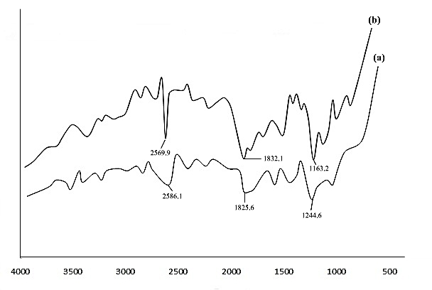
Wavenumber (cm⁻¹)
Transmittance (%)

Figure 1: FTIR Spectra of ADFX (a) after biosorption (b) before biosorption
3.2. Experimental design summary
The D-optimal design suggested a quadratic model which consists of eighteen experimental runs (18). Run 14 with selected factors; 60 min, 200mg/L and 0.60g which correspond to the t_{c}, C_{o} and B_{d}, respectively have the highest percentage removal (73.33%) while the highest adsorption capacity of 0.434 mg/g at selected factors of 60 min, 200 mg/L, and 0.20 g was obtained at run 17. However, the lowest percentage removal (4.848 %) and adsorption capacity (0.125 mg/g) were obtained at run 7 and 12, respectively. The results of the diagnostic case studies (Table 3) indicate that the difference between the predicted and actual values for adsorption capacity and percentage removal was small which shows an elevated value of R² [16]. The results obtained for the normal plot of residuals for both responses (Adsorption capacity and percentage removal) (Figure 2 a-b) show the data points were within a straight line and the level of stacking was less. High R² was also obtained from the plot of the relationship between the predicted and actual values for both adsorption capacity and percentage removal (Figure 3 a-b).
Table 3: D-optimal design and diagnostic case statistics for the responses
Run | Factors |  |  |  | Responses
 | t_{c} (min) | C_{o} (mg/L) | B_{d} (g) |  | Adsorption Capacity (mg/g) |  |  |  | percentage removal
 |  |  |  |  | Actual Value | Predicted value | Residual |  | Actual Value | Predicted value | Residual
1 | 120 | 150 | 0.4 |  | 0.176 | 0.217 | -0.041 |  | 64.444 | 50.817 | 13.63
2 | 120 | 50 | 0.2 |  | 0.142 | 0.170 | -0.024 |  | 11.515 | 10.813 | 0.702
3 | 60 | 150 | 0.6 |  | 0.154 | 0.184 | -0.030 |  | 68.889 | 57.069 | 11.82
4 | 90 | 150 | 0.2 |  | 0.235 | 0.271 | -0.036 |  | 52.525 | 37.478 | 15.05
5 | 120 | 50 | 0.2 |  | 0.142 | 0.170 | -0.028 |  | 13.939 | 10.813 | 3.126
6 | 120 | 200 | 0.6 |  | 0.178 | 0.218 | -0.040 |  | 73.030 | 76.308 | -3.278
7 | 60 | 50 | 0.2 |  | 0.157 | 0.184 | -0.027 |  | 4.848 | 6.088 | -1.24
8 | 90 | 100 | 0.5 |  | 0.158 | 0.154 | 0.004 |  | 52.121 | 39.430 | 12.69
9 | 60 | 50 | 0.2 |  | 0.155 | 0.184 | -0.029 |  | 6.061 | 6.088 | -0.027
10 | 120 | 200 | 0.2 |  | 0.357 | 0.311 | 0.046 |  | 45.909 | 54.354 | -8.445
11 | 90 | 50 | 0.4 |  | 0.132 | 0.130 | 0.002 |  | 20.00 | 19.428 | 0.5722
12 | 120 | 50 | 0.6 |  | 0.125 | 0.077 | 0.048 |  | 24.24 | 32.767 | -8.525
13 | 60 | 200 | 0.4 |  | 0.284 | 0.278 | 0.006 |  | 56.970 | 60.606 | -3.636
14 | 60 | 200 | 0.6 |  | 0.176 | 0.231 | -0.055 |  | 73.333 | 71.583 | 1.75
15 | 120 | 50 | 0.6 |  | 0.126 | 0.077 | 0.049 |  | 23.636 | 32.767 | -9.131
16 | 120 | 200 | 0.2 |  | 0.316 | 0.311 | 0.005 |  | 52.121 | 54.354 | -2.232
17 | 60 | 200 | 0.2 |  | 0.434 | 0.325 | 0.109 |  | 34.242 | 49.629 | -15.39
18 | 60 | 50 | 0.6 |  | 0.131 | 0.090 | 0.041 |  | 20.606 | 28.042 | -7.436

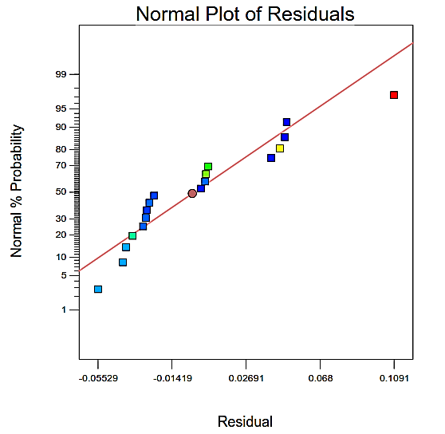  (a) | 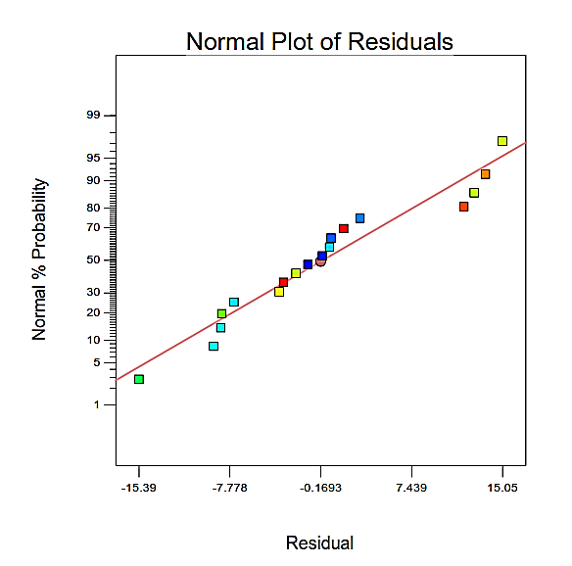  (b)
Figure 2: Residual Normal plot for (a) adsorption capacity and (b) percentage removal

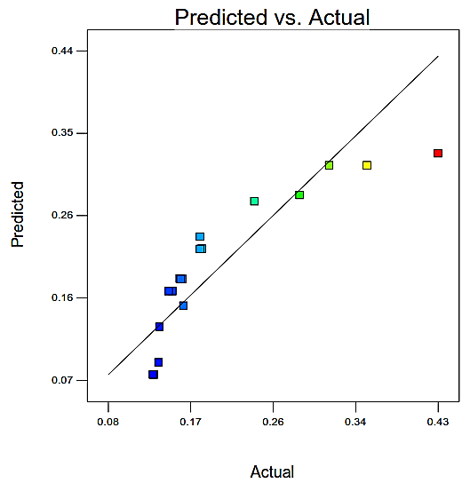  (a) | 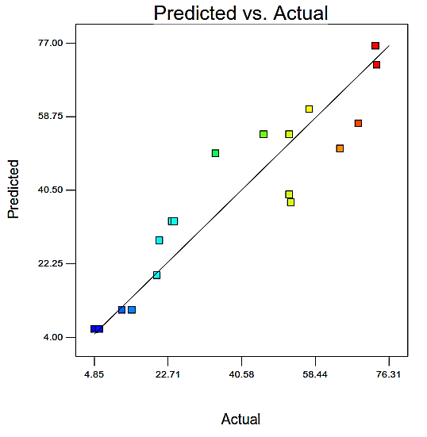  (b)
Figure 3: Predicted against actual plot (a) adsorption capacity and (b) percentage removal

The R² obtained for adsorption capacity and percentage removal were 0.8052 and 0.8830 while the corresponding adjusted R² were 0.7634 and 0.8580. The R², which should be close to one (1), demonstrates the extent to which response in the model has diminished. A large R² value implies that the generated model equation reflects the process reasonably and can be used for theoretical model representation [17]:
$Adsorption Capacity=0.20-6.795×{10}^{-3}A+0.071B-0.047C$ (7)
$Percentage Removal=41.20+2.36A+21.77B+10.98C$ (8)

3.3. Three-dimensional plot of the surface interaction
From Figure 4a, the adsorption capacity of the ADFX increased when the C_{o} increased while the t_{c} reduced. However, the percentage of removal increased when both C_{o} and t_{c} increased. Furthermore, the percentage removal increased when the t_{c} and B_{d} were increased while the adsorption capacity only increased when the t_{c} was reduced while the B_{d} increased (Figure 4b).

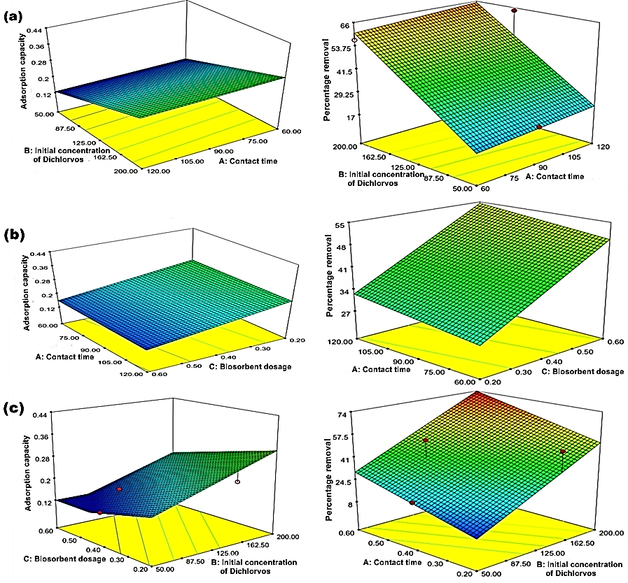
Figure 4: Three-dimensional surface plot revealing the influence of (a) initial concentration of Dichlorvos (C_{o}) and contact time (t_{c}) on adsorption capacity and percentage removal (b) contact time (t_{c}) and biosorbent dosage (B_{d}) on adsorption capacity and percentage removal (c) biosorbent dosage (B_{d}) and initial concentration of Dichlorvos (C_{o}) on adsorption capacity and percentage removal

The percentage removal also increased when the C_{o} and B_{d} were increased while the adsorption capacity only increased when the B_{d} was lessened while the C_{o} also increased (Figure. 4c). The surface of the three-dimensional plots was flat; this implies a direct correlation between the factors selected [18]. This is apparent from the software's regression analytical model (Table 4).

Table 4: Biosorption ANOVA
Adsorption Capacity
Source | Sum of Squares | DF | Mean Square | F Value | Prob> F
Model | 0.11 | 3 | 0.035 | 15.34 | 0.0001*
A- t_{c} | 6.843E-004 | 1 | 6.843E-004 | 0.30 | 0.5930
B- C_{o} | 0.071 | 1 | 0.071 | 31.12 | < 0.0001*
C- B_{d} | 0.031 | 1 | 0.031 | 13.47 | 0.0025*
Residual | 0.032 | 14 | 2.287E-003 |  | NA
Lack of Fit | 0.031 | 10 | 3.116E-003 | 14.65 | 0.0099*
Pure Error | 8.510E-004 | 4 | 2.127E-004 | NA | NA
Cor Total | 0.14 | 17 | NA | NA | NA
Adequate Precision = 11.018, R² = 0.7668, Adj. R² = 0.7168, Predicted R² = 0.5807
Percentage Removal
Model | 8308.95 | 3 | 2769.65 | 30.38 | < 0.0001*
A- t_{c} | 82.74 | 1 | 82.74 | 0.91 | 0.3570
B- C_{o} | 6768.10 | 1 | 6768.10 | 74.23 | < 0.0001*
C- B_{d} | 1694.31 | 1 | 1694.31 | 18.58 | 0.0007*
Residual | 1276.44 | 14 | 91.17 | NA | NA
Lack of Fit | 1253.29 | 10 | 125.33 | 21.65 | 0.0047*
Pure Error | 23.15 | 4 | 5.79 | NA | NA
Cor Total | 9585.39 | 17 | 2769.65 | 30.38 | < 0.0001
Adequate Precision = 15.600, R² = 0.8668, Adj. R² = 0.8383, Predicted R² = 0.7920
NA- Not Applicable *Significant at P (prob>F) 0.05

3.4. Optimization studies
The model equations (eqn. 8 and 9) representing the objective functions were subjected to the constraint indicated in Table 5. The highest desirability (0.666) was achieved at the maximum adsorption capacity and percentage removal of 0.3113 mg/g and 54.35%, respectively at 120 min t_{c}, 200 mg/L C_{o,} and 0.20 g B_{d}. The result of the validation at the achieved optimum process condition (Table 6) shows a close relationship between simulated and analytical values of adsorption capacity and percentage removal with a 1.12% and 1.16% error difference. These variations are less than 10% and justify the suitability of the design [19].
3.5. Effect of contact time (t_{c}) and initial concentration of Dichlorvos (C_{o})
The plot of q_{e} against t (Figure 5) shows that the adsorption capacity of the ADFX increased steadily with an increase in both t_{c} and C_{o}. The removal of Dichlorvos was faster in the first 10 min with the uptake of 1.33, 2.08, and 2.75 mg/g at 30, 40, and 50 mg/L C_{o}. The extent of biosorption reduces as the contact time increases steadily until it nearly reached equilibrium when both adsorption and desorption rates tend to be equal [20]. The increase in biosorption was due to the increase in concentration gradient [21] and increased vacant sites on the ADFX [22]. The biosorption process reached equilibrium at 210 min and a maximum adsorption capacity of 1.68, 2.87, and 5.20 mg/g, respectively were achieved. The percentage of removal also increased with increasing t_{c} and C_{o}. The highest percentage removal of 34.16, 43.75, and 64.4% were obtained at 30, 40, and 50 mg/L C_{o}, respectively.

Table 5: Subject constraints for the numerical optimization Study
Name | Goal | Lower Limit | Upper Limit
t_{c} (min) | is in range | 60 | 120
Co (mg/L) | is in range | 50 | 200
B_{d} (g) | is in range | 0.2 | 0.6
Adsorption capacity (mg/g) | Maximize | 0.125 | 0.434
Percentage removal (%) | Maximize | 4.848 | 73.33
Table 6: Correlation between the simulated and analytical value
 | t_{c} (min) | Co (mg/L) | B_{d} (g) | Adsorption capacity (mg/g) | Percentage removal (%)
Analytical | 58.50 | 196 | 0.22 | 0.3278 | 50.50
Simulation | 60.07 | 200 | 0.20 | 0.3382 | 51.04

Figure 5: Effect of t_{c} and C_{o} on adsorption capacity and percentage removal (PR)
3.6. Effect of biosorbent dosage (B_{d})
At the different initial concentrations of Dichlorvos (30, 40, and 50 mg/L), the adsorption capacity and percentage removal increased with an increase in B_{d} (Figure 6). This was because more adsorption sites on the ADFX became available [23].
3.7. Effect of temperature
As presented in Figure 7, the uptake of Dichlorvos by the ADFX rises as the temperature also rises to a certain level. The increase in adsorption capacity and percentage removal with temperature was an indication that the active surface sites on the ADFX have increased with temperature [24]. The extent of biosorption reduces as the contact time increases steadily until it nearly reached equilibrium when the rates of adsorption and desorption tend to be equal. Increasing temperature allows the aggregation process to exceed a certain temperature limit in a specified manner, above which desorption becomes more significant, thereby lessening the biosorption rate as time passes by. The process attains equilibrium at 100 min t_{c} with the highest adsorption capacity of 6.99, 7.30, and 7.40 mg/g at 30, 40, and 50 ºC, respectively.
Figure 6: Effect of B_{d} on adsorption capacity and percentage removal
Figure 7: Effect of temperature on adsorption capacity and percentage removal
3.8. Analysis of adsorption isotherm
The model plots for the isotherms are presented in Figure 8 and the calculated parameters are presented in Table 7. The Langmuir isotherm (Figure 8a) suggests monolayer biosorption on the biosorbent surface, with a limited number of uniform adsorption sites. The biosorption involves a comparable mechanism with relations between the adsorbate molecules [25]. The Freundlich isotherm (Figure 8b) is an analytical model that is based on the basic assumption that the biosorption happens on a heterogeneous surface or that the biosorbent affinity differs over the biosorbent surface [26]. The best isotherm model was selected based on the model with the highest R². Therefore, the Freundlich isotherm with an R² value of 0.9998, and the best isotherm fitting (Figure 8b) perform better than Langmuir, Dubinin Radushkevich, and Harkins-Jura with corresponding R² values of 0.8973, 0.9626, and 0.9283.
This is an indication that uptake of Dichlorvos molecules occurs at the heterogeneous surface of the ADFX and the interaction of the Dichlorvos molecules adsorbed follows the Freundlich model [27]. Also, since the ∩ which is Freundlich constant that denotes surface heterogeneity in the adsorption process is less than 1 (0.5841) then it is evident that chemisorption is desirable. Comparisons of the calculated Freundlich parameters with other studies are presented in Table 8.

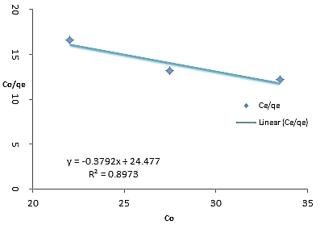 | 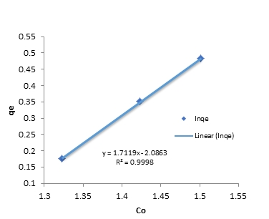
(a) | (b)
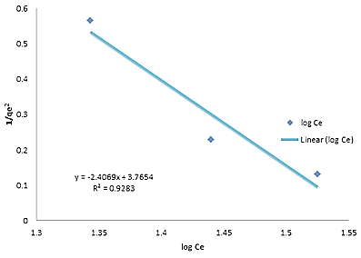 | 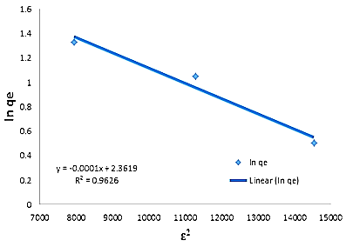
(c) | (d)
Figure 8: Isotherm plot (a) Langmuir (b) Freundlich (c) Harkin-Jura (d) Dubinin-Radushkevich

3.9. Analysis of kinetics and Diffusion mechanism
To study the biosorption kinetics, three models were used (PFO, PSO, and Elovich kinetic models). The plots of the models are presented in Figure 9(a-c). The adsorption rate constants, K₁ (Table 9) for the PFO were obtained by plotting $\log{{ (q}_{e}-q_{t})}$ against t (Figure 9a) while K₂ (Table 9) for the PSO was obtained by plotting $\frac{t}{q_{t}}$ against t (Figure 9b). Also, the Elovich constant $α$ and $β_{E}$ (Table 9) were obtained from the plot of $q_{t}$ against $\ln{t}$ (Figure 9c). The value of K₁ obtained at 30, 40 and 50 mg/L C_{o} are 0.0028, 0.0046, 0.0062 min⁻¹, respectively. This shows that the rate of adsorption increased with an increase in Co while the adsorption capacity at equilibrium decreased. The values obtained for K₂ (2.5574, 2.9674, 5.4259 min⁻¹), $α$ (1745.7, 373.03, 18.048 mg/gmin²) and $β_{E}$ (15.221, 4.4683, 1.6111mg/g) show a similar trend.
The criteria for selecting the best kinetics that represents the biosorption of the Dichlorvos onto the ADFX are the coefficient of determination (R²) [28]. The closeness of the R² value to unity makes the model the best fit. In this study, Elovich with the highest R² values (0.9730, 0.9454, and 0.8991) at 30, 40, and 50 mg/L C_{o} is the best model that describes the kinetics for the biosorption of Dichlorvos onto ADFX. The possible involvement of particle diffusion during Dichlorvos biosorption was confirmed by greater R² values obtained for Webber-Morris diffusion (WMD), Dumwald-Wagner diffusion (DWD), and McKay film diffusion (MFD) models plot (Figure 9d-f). The WMD model plot displayed multi-linearity (Figure 9d). The values of$K_{wm},$ $K_{DW}$, $K_{m}$ and C (Table 9) were obtained from the slope and intercept of the plots in Figure 9 (d-f). The biosorption mechanism was depicted by the values of C while K_{wm}, $K_{DW}$ and $K_{m}$are the rate factors [29]. A higher value of C indicates better biosorption (Mathangi and Kalavathy, 2018). Since the plot of WMD pass through the origin, then it can be inferred that the process was controlled by particle diffusion while the rate-limiting steps are MFD and DWD [30].

Table 7: Parameter of isotherm models for biosorption
Isotherms | Parameter | ATDX
Langmuir | Q_{m} calculated (mg/g) | -2.6374
 | K_{e}(mg/g) | -0.0155
 | R² | 0.8973
Freundlich | K_{f} (mg/g) | 0.1242
 | 1/n | 1.7119
 | n | 0.5842
 | R² | 0.9998
Dubinin-Radushkevich | q_{m} (mg/g) | 10.611
 | R² | 0.9626
 | β | 0.0001
 | ε | 0.1714
Harkins-Jura | A | 0.4155
 | B | 1.5644
 | R² | 0.9283

3.10. Adsorption thermodynamics
The plot of lnK_{d} against I/T (Figure 10) was used to determine the thermodynamic properties (Table 10). The positive values of $∆H$ show that the biosorption process was endothermic and therefore, a rise in temperature leads to an increase in the adsorption rate of diffusion of the Dichlorvos through the layer to the internal pore of the biosorbent. Since the value for the $∆H$ obtained at various C_{o} was less than 40 KJ/mol, the mechanism for the biosorption of the Dichlorvos by the biosorbent follows physisorption [34]. The negative values obtained for the change in entropy indicate that the degree of disorderliness during biosorption decreases at the solid-liquid interface [35].

$${log⁡(q}_{e-}q_{t})$$
(a) | (b) | (c)
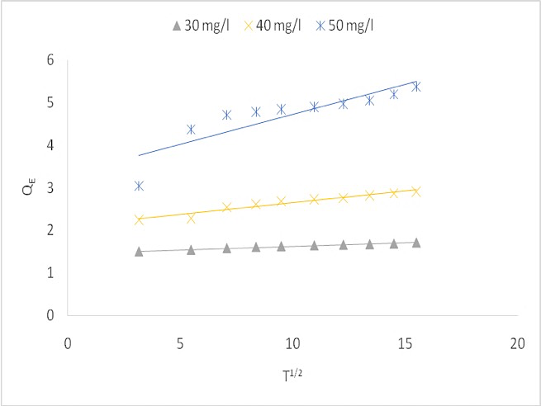 | 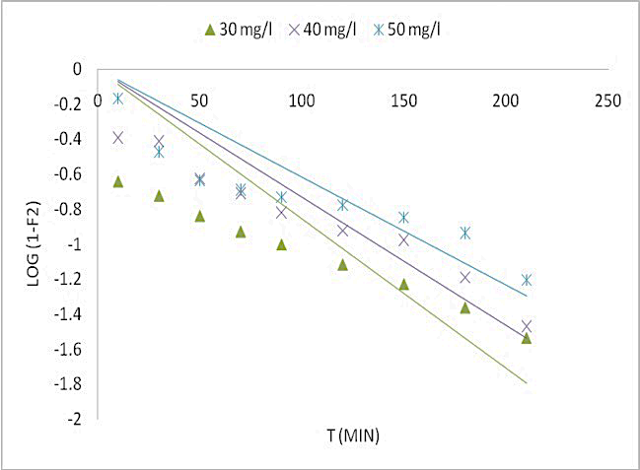 | 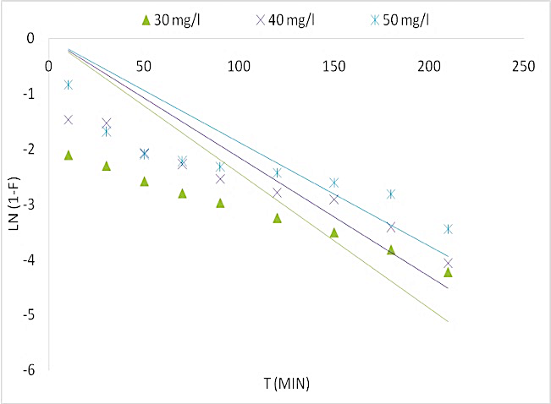
(d) | (e) | (f)
Figure 9: Adsorption kinetics plot (a) PFO (b) PSO (c) Elovich (d) WMD (e) DWD and (f) MFD

Table 8: Comparison of Freundlich parameter obtained for Dichlorvos biosorption with other reported adsorbates
Adsorbate | Biosorbent | Parameter determined |  |  | Reference
 |  | $$K_{f}$$ | n | $$R^{2}$$
Dichlorvos | ADFX | 0.1241 | 0.5841 | 0.9998 | Present study
2, 4-D | OP | 5.94 | 1.88 | 0.9731 | [31]
 | MW | 5.93 | 2.19 | 0.9897
 | AS | 7.29 | 3.65 | 0.8954
 | BP | 4.72 | 2.22 | 0.9571
Oxamyl | SFAC | 27.906 | 1.16 | 0.9975 | [32]
Malathion | Phyllantus niruri | 0.6569 | 1.0930 | 0.9987 | [33]

Table 9: Kinetic and mass transfer diffusion models parameters
Kinetic model
C_{o}  (mg/L) | $$q_{e,exp}$$  (mg/g) | PFO |  |  | PSO |  |  |  |  |  | Elovich
 |  | $$q_{e, cal}$$  (mg/g) | $$k_{1}$$  $${(min}^{-1})$$ | $$R^{2}$$ |  | $$q_{e, cal}$$  (mg/g) |  | $$k_{2}$$  $${(min}^{-1})$$ | $$R^{2}$$ |  |  |  | α  $${(mgg}^{-1}$$  $$\min^{-2})$$ |  |  | $$β_{E}$$  $${(mgg}^{-1})$$ |  | $$R^{2}$$
30 | 1.7083 | 2.5574 | 0.0028 | 0.9633 |  | 1.7083 |  | 2.5574 | 0.1427 |  |  |  | 1745.7 |  |  | 15.221 |  | 0.9730
40 | 2.9167 | 0.9423 | 0.0046 | 0.9439 |  | 2.9167 |  | 2.9674 | 0.0414 |  |  |  | 373.03 |  |  | 4.4683 |  | 0.9454
50 | 5.3667 | 0.5514 | 0.0062 | 0.8445 |  | 5.3667 |  | 5.4259 | 0.0019 |  |  |  | 18.048 |  |  | 1.6111 |  | 0.8991
Diffusion models
C_{o}  (mg/L) | WMD |  |  |  |  |  | DWD |  |  |  |  |  |  |  | MFD
 | $K_{wm}$ ${(mg/gmin}^{0.5})$ |  |  | $$C$$ | $$R^{2}$$ |  | $$K_{DW} (\min^{-1})$$ |  |  | $$R^{2}$$ |  |  |  | $$K_{m} (\min^{-1})$$ |  |  | $$R^{2}$$
30 | 0.0163 |  |  | 1.4574 | 0.9858 |  | 0.0196 |  |  | 0.7704 |  |  |  | 0.0242 |  |  | 0.3607
40 | 0.0549 |  |  | 2.0994 | 0.9391 |  | 0.0177 |  |  | 0.7805 |  |  |  | 0.0225 |  |  | 0.3873
50 | 0.1397 |  |  | 3.3222 | 0.7520 |  | 0.0143 |  |  | 0.7039 |  |  |  | 0.0189 |  |  | 0.1137
PFO: Pseudo First Order, PSO: Pseudo Second Order, WMD: Weber Morris Diffusion, MFD: McKay Film Diffusion and DWD: Dumwald-Wagner Diffusion

Figure 10/ plot of InK_{d} vs I/T

Table 10. Thermodynamic parameter for adsorption of DDVP
Conc  mg/l | Temp  (˚C) | K_{d} | lnk_{d} | ∆G  (J/mol) | ∆H  (J/mol) | ∆S  (J/mol.K)
30 | 30 | 0.04336 | -3.13801 | 7905.08 | 5328.69 | -8.50688
 | 40 | 0.04634 | -3.07172 | 7993.48
 | 50 | 0.04944 | -3.007 | 8075.07
40 | 30 | 0.07094 | -2.64592 | 6665.44 | 195.92 | -21.3936
 | 40 | 0.07003 | -2.6588 | 6918.96
 | 50 | 0.07130 | -2.64077 | 7091.59
50 | 30 | 0.07271 | -2.62125 | 6603.31 | 3996.12 | -8.54845
 | 40 | 0.07809 | -2.54984 | 6635.40
 | 50 | 0.08018 | -2.52348 | 6776.61

4. Conclusion
ADFX biosorbent has been developed and deployed successfully for the biosorption of Dichlorvos from an aqueous solution. The effectiveness of the ADFX has been found to depend greatly on contact time (t_{c}), initial concentration of Dichlorvos (Co), and the dosage of the biosorbent (B_{d}). The analytical and simulated data obtained for the biosorption of Dichlorvos shows a close correlation with an error difference of less than 5%. An optimal condition for biosorption based on percentage removal of 52.04% and adsorption capacity of 0.3382 mg/g were 60.07 min t_{c}, 200 mg/L Co and 0.20 g B_{d}. The biosorption isotherm and kinetics fitted greatly with the Freundlich isotherm and Elovich models. Also, the diffusion mechanism indicates the film diffusion as the rate-controlling step while the thermodynamics shows that the process was endothermic and the degree of disorderliness decreases at the solid-liquid interface during biosorption. For future studies, the usability of Acid-Activated Tithonia diversifolia Xylem for Dichlorvos removal from real wastewater will be tested and as comparison, a fixed bed column will be employed to investigate the effect of reactor design.
Notations and Abbreviations
${α (mgg}^{-1}\min^{-2})$: Initial biosorption rate  $β_{E}{(mgg}^{-1})$ : Desorption constant.  $B_{d}(g)$: Biosorbent dose  $C_{t}(min)$: Contact time  $K_{DW}(\min^{-1})$: Dumwald-Wagner diffusion rate constant  $K_{f}$: Freundlich constant  $K_{m}(\min^{-1})$: McKay film diffusion rate constant  $K_{wm }\left(mg/g\min^{0.5}\right):$Webber–Morris diffusion rate constant  $c_{e}({mg}/L)$: Dichlorvos concentration at equilibrium time  $c_{o}({mg}/L)$: Dichlorvos concentration at initial state (t=0)  $k_{1}$(L/min): Pseudo- first-order rate constant  $k_{2}$ (g/mg.min): Pseudo-second order rate constant  $k_{d}$: Equilibrium constant.  $q_{DR}{(mg}/g)$: Dubinin–Radushkevich model adsorbate equilibrium concentration  $q_{e}\left(mg/g\right):$ Adsorption capacity at equilibrium  $q_{m}(mg/g)$: Maximum monolayer coverage adsorption capacity  $q_{t}{(mg}/g)$: Adsorption capacity at time t  ∆Gº ($J/{mol}$): Free energy change  ∆Hº ($J/{mol}$): Change in enthalpy  ∆Sº ($J/{mol K}$): Change in entropy  ∩: Freundlich constant, | 2, 4-D: 2, 4-dichlorophenoxy acetic acid  A: Harkins-Jura constant  AP: Apple shell  B: Harkins-Jura constant  BP: Banana peel  DWD: Dumwald-Wagner Diffusion  K_{L} (L/mg): Biosorption free energy constant  MFD: McKay Film Diffusion  MW: Millet waste  OP: Orange peel  PE (%): Percentage removal  PFO: Pseudo First Order  PSO: Pseudo Second Order  R ($J/{mol K})$: Molar gas constant  R²: Correlation coefficient  SFAC: Silkworm faeces activated carbon  t_{c} (min): Contact time  T_{p} (K): Temperature  WMD: Weber Morris Diffusion  $C \left(mg/g\right)$: Weber-Morris constant  $F=\frac{q_{t}}{q_{e}}$: Biosorption percentage  $V(L)$: Volume of the synthetic wastewater  $m\left(g\right):$ Mass of the biosorbent  $β({KJ}^{2}{mol}^{2})$: Free energy of sorption/mole of adsorbate  $ε({Jmol}^{-1})$: Polanyi potential

References
- S. Sun, V. Sidhu, Y. Rong, and Y. Zheng, “Pesticide Pollution in Agricultural Soils and Sustainable Remediation Methods: a Review”. Current Pollution Reports, 4(3) (2018) 240-250. https://doi.org/10.1007/s40726-018-0092-x
- F, Kandie, M. Krauss, L. Beckers, R. Massei, U. Fillinger, J. Becker, M. Liess, B. Torto, and W. Brack, “Occurrence and risk assessment of organic micropollutants in freshwater systems within the Lake Victoria South Basin, Kenya”. Science of The Total Environment, 714, (2020) 136748. https://doi.org/10.1016/j.scitotenv.2020.136748
- M. El-Alfy, A. Hasballah, H. Abd El-Hamid, and A. El-Zeiny, “Toxicity assessment of heavy metals and organochlorine pesticides in freshwater and marine environments, Rosetta area, Egypt using multiple approaches”. Sustainable Environment Research, 29(1) (2019) https://doi.org/10.1186/s42834-019-0020-9
- J. Kaushal, M. Khatri, and S. Arya, “A treatise on Organophosphate pesticide pollution: Current strategies and advancements in their environmental degradation and elimination”. Ecotoxicology and Environmental Safety, 207, (2020) 111483. https://doi.org/10.1016/j.ecoenv.2020.111483
- R. Jain, M. Camarillo, and W. Stringfellow, Threats. Drinking Water Security for Engineers, Planners, and Managers, (2014) 45-67. https://doi.org/10.1016/B978-0-12-411466-1.00003-3
- A. Vacca, L. Mais, M. Mascia, E.M., Usai, and S. Palmas, “Design of Experiment for the Optimization of Pesticide Removal from Wastewater by Photo-Electrochemical Oxidation with TiO₂ Nanotubes”. Catalysts, 10(5) (2020) 512. https://doi.org/10.3390/catal10050512
- A. Ismael, A. El-Shazly, S. Gaber, M. Rashad, A. Kamel, and S. Hassan, “Novel TiO₂/GO/CuFe₂O₄ nanocomposite: a magnetic, reusable, and visible-light-driven photocatalyst for efficient photocatalytic removal of chlorinated pesticides from wastewater”. RSC Advances, 10(57) (2020) 34806-34814. https://doi.org/10.1039/D0RA02874F
- G. Luna-Sanguino, A. Ruíz-Delgado, A. Tolosana-Moranchel, L. Pascual, S. Malato, A. Bahamonde, and M. Faraldos, “Solar photocatalytic degradation of pesticides over TiO₂-rGO nanocomposites at pilot plant scale”. Science of The Total Environment, 737 (2020) 140286. https://doi.org/10.1016/j.scitotenv.2020.140286
- N. Hoang, and R. Holze, “A Combination of Electrochemical and Adsorption Techniques for Degradation and Removal of Pesticide Padan 95SP (95% Cartap) from Water”. Russian Journal of Electrochemistry, 56(6) (2020) 492-505. https://doi.org/10.1134/S1023193520060087
- A.R. Amole, D.O. Araromi, A.O. Alade, T.J. Afolabi, and V.A. Adeyi, “Biosorptive removal of nitrophenol from aqueous solution using ZnCl₂-modified groundnut shell: optimization, equilibrium, kinetic, and thermodynamic studies”. International Journal of Environmental Science and Technology. (2020). https://doi.org/10.1007/s13762-020-02939-y
- Y. Birhanu, S., Leta, and G, Adam, “Removal of chromium from synthetic wastewater by adsorption onto Ethiopian low-cost Odaracha adsorbent”. Applied Water Science, 10(11) (2020) https://doi.org/10.1007/s13201-020-01310-3
- J.M. Salman “Optimization of preparation conditions for activated carbon from palm oil fronds using response surface methodology on removal of pesticides from aqueous solution”. Arabian Journal of Chemistry, 7: (2014) 101–108. https://doi.org/10.1016%2Fj.arabjc.2013.05.033
- P. Devi, A.K. Dalai, and S.P. Chaurasia, “Activity and stability of biochar in hydrogen peroxide-based oxidation system for degradation of naphthenic acid”. Chemosphere, 241, (2020) 125007. https://doi.org/10.1016/j.chemosphere.2019.125007
- I. Dindarloo, M.S. Iman, H, Eslahi, and M. Esmaeilpour, “N-Arylation of (Hetero)arylamines Using Aryl Sulfamates and Carbamates via C−O Bond Activation Enabled by Reusable and Durable Nickel Catalyst”. New Journal of Chemistry. (2020). https://doi.org/10.1039/d0nj01610a
- H. Chandarana, S. Suganya, and A.K. Madhava, Surface functionalized Casuarina equisetifolia pine powder for the removal of hetero-polyaromatic dye: characteristics and adsorption. International Journal of Environmental Analytical Chemistry, 1–15 (2020) https://doi.org/10.1080/03067319.2020.1798418
- S. Duangjit, W. Chairat, P. Opanasopit, T. Rojanarata, and T. Ngawhirunpat, Application of Design Expert for the investigation of capsaicin-loaded microemulsions for transdermal delivery. Pharmaceutical Development and Technology, 1–8 (2015) https://doi.org/10.3109/10837450.2015.104855
- A. Hafizi, A. Ahmadpour, M.M. Heravi, F.F. Bamoharram, and M. Khosroshahi, “Alkylation of Benzene with 1-Decene Using Silica Supported Preyssler Heteropoly Acid: Statistical Design with Response Surface Methodology”. Chinese Journal of Catalysis, 33(2-3) (2012) 494–501. https://doi.org/10.1016/S1872-2067(11)60357-4
- V. Mabayo, J. Aranas, V. Cagas, D. Cagas, A. Ido, and R. Arazo, “Optimization of oil yield from Hevea brasiliensis seeds through ultrasonic-assisted solvent extraction via response surface methodology”. Sustainable Environment Research, 28(1) (2018) 39-46. https://doi.org/10.1016/j.serj.2017.08.001
- A. Ya’acob, and N. Zainol, “Application of central composite design for optimization of microbial growth inhibition using pineapple leaves juice”. IOP Conference Series: Materials Science and Engineering, 863, (2020) 012022. https://doi.org/10.1088/1757-899X/863/1/012022
- M. Rai, G. Shahi, V. Meena, R. Meena, S. Chakraborty, and B. Rai, “Removal of hexavalent chromium Cr (VI) using activated carbon prepared from mango kernel activated with H₃PO₄”. Resource-Efficient Technologies, 2, (2016) S63–S70. https://doi.org/10.1016/j.reffit.2016.11.011
- E, Malkoc, Y. Nuhoglu, and M. Dundar, “Adsorption of Chromium (VI) on pomace-An olive oil industry waste: batch and column studies”. Journal of Hazardous Materials, 138, (2006) 142–151 https://doi.org/10.1016/j.carres.2020.108153
- M.T. Uddin, M.A. Rahman, M. Rukanuzza man, and M.A. Islam, “A potential low-cost adsorbent for the removal of cationic dyes from aqueous solutions”. Applied Water Science, 7(6) (2017) 2831–2842. https://doi.org/10.1007/s13201-017-0542-4
- J. Yang, M. Yu, and W. Chen, “Adsorption of hexavalent chromium from aqueous solution by activated carbon prepared from longan seed: kinetics, equilibrium, and thermodynamics”. Journal of Industrial and Engineering Chemistry, 21 (2015) 414–422 doi.org/10.1016/j.jiec.2014.02.054
- S. Mnasri-Ghnimi, and N. Frini-Srasra, “Removal of heavy metals from aqueous solutions by adsorption using single and mixed pillared clays”. Applied Clay Science, 179, (2019) 105151. https://doi.org/10.1016/j.clay.2019.105151
- H.K. Boparai, M. Joseph, and D.M. O’Carroll, “Kinetics and thermodynamics of cadmium ion removal by adsorption onto nanozerovalent iron particles”. J. Hazard. Mater.,186, (2011) 458−465. https://doi.org/10.1016/j.jhazmat.2010.11.029
- A. Lim, J. Chew, L. Ngu, S. Ismadji, D., Khaerudini, and J. Sunarso, “Synthesis, Characterization, Adsorption Isotherm, and Kinetic Study of Oil Palm Trunk-Derived Activated Carbon for Tannin Removal from Aqueous Solution”. ACS Omega, 5(44) (2020) 28673-28683. https://doi.org/10.1021/acsomega.0c03811
- S. Gholamiyan, M. Hamzehloo, and A. Farrokhnia, “RSM optimized adsorptive removal of erythromycin using magnetic activated carbon: Adsorption isotherm, kinetic modeling, and thermodynamic studies”. Sustainable Chemistry and Pharmacy, 17, (2020) 100309. https://doi.org/10.1016/j.scp.2020.100309
- M. De la Luz-Asunción, E.E. Perez-Ramirez, A.L. Martinez-Hernandez, P.E. García-Casillas, J.G. Luna-Bárcenas, and C. Velasco-Santos, C. “Adsorption and kinetic study of Reactive Red 2 dye onto graphene oxides and graphene quantum dots”. Diamond and Related Materials, (2020) 108002. https://doi.org/10.1016/j.diamond.2020.108002
- E. Dermirbas, M. Kobya, E. Senturk, and T. Ozkan. Adsorption Kinetics for the removal of Chromium (VI) from aqueous solutions on the activated carbons prepared from agricultural wastes. Water SA 30(4) (2004) 533-539
- J. Mathangi, and M. Kalavathy, “Optimization of process parameters for the adsorption of nickel onto activated carbon using response surface methodology”. desalination and water treatment, 115: (2018) 115-125. https://doi.org/10.5004/dwt.2018.22437
- V. Okumuş, K. Çelik, S. Özdemir, A. Dündar, and E. Kılınç, “Biosorption of chlorophenoxy acid herbicides from aqueous solution by using low-cost agricultural wastes”. Desalination and Water Treatment, 56(7) (2014) 1898-1907. https://doi.org/10.1080/19443994.2014.961562
- S. Mohammad, and S. Ahmed, “Preparation of environmentally friendly activated carbon for removal of pesticide from aqueous media”. International Journal of Industrial Chemistry, 8(2), (2017) 121-132. https://doi.org/10.1007/s40090-017-0115-2
- T. Yadamari, K. Yakkala, G. Battala, and R.N. Gurijala, Biosorption of Malathion from Aqueous Solutions Using Herbal Leaves Powder. American Journal of Analytical Chemistry, 02(08) (2011) 37–45. https://doi.org/10.4236/ajac.2011.228122
- M. Khan, S. Kim, R. Rao, R. Abou-Shanab, A. Bhatnagar, H. Song, and B. Jeon, “Adsorption studies of Dichloromethane on some commercially available GACs: Effect of kinetics, thermodynamics, and competitive ions”. Journal of Hazardous Materials, 178(1-3), (2010) 963-972. https://doi.org/10.1016/j.jhazmat.2010.02.032
- N. Mojoudi, N. Mirghaffari, N. Soleimani, H. Shariatmadari, C. Belver, and J. Bedia, “Phenol adsorption on high microporous activated carbons prepared from oily sludge: equilibrium, kinetic and thermodynamic studies”. Scientific Report, 9, (2019) 19352. https://doi.org/10.1038/s41598-019-55794-4
(2022) ; http://www.jmaterenvironsci.com

