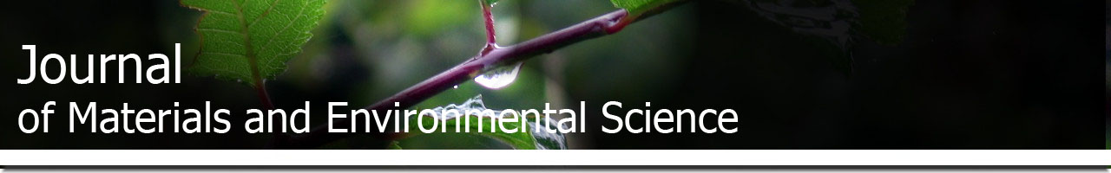
COPYRIGHT FORM

Journal of Materials and Environmental Science
(J. Mater. Environ. Sci.) ; JMES, http://www.jmaterenvironsci.com
Email : jmes2015accepted@gmail.com

Manuscript Ref: JMES-2020-11-

Title :……………………………………………….…………………………………………………... …………………………………………………….…………………………………………………….…….………………………………………………………….………………………………………………………….………………………………………………………….………………………………

Corresponding author: ………………………………………………….............................................

Names of co-authors + email :

The author(s) acknowledged that the manuscript submitted is original work; all authors participated in the work in a substantive way and are prepared to take public responsibility for the work; all authors have seen and approved the manuscript as submitted; the manuscript has not been published and is not being submitted or considered for publication elsewhere.

Notwithstanding the above, the Contributor(s) or, if applicable the Contributor’s Employer, retain(s) all proprietary rights other than copyright, such as Patent rights; to use, free of charge, all parts of this article for the author’s future works in books, lectures, classroom teaching or oral presentations; the right to reproduce the article for their own purposes provided the copies are not offered for sale.

If the paper is not published in the Journal, the rights revert to the Author as original copyright holder

I/We indemnify Journal of Materials and Environmental Science (ISSN: 2028-2508) and the Editors, and hold them harmless from any loss, expense or damage occasioned by a claim or suit by a third party for copyright infringement, or any suit arising out of any breach of the foregoing warranties as a result of publication of my/our article. I/We also warrant that the article contains no libelous or unlawful statements and does not contain material or instructions that might cause harm or injury.

Date Place (Corresponding Author)

